UNITED STATES
SECURITIES AND EXCHANGE COMMISSION
Washington, D.C. 20549

FORM 8-K

CURRENT REPORT

Pursuant to Section 13 OR 15(d) of The Securities Exchange Act of 1934
Date of Report (date of earliest event reported): September 15, 2026

West Coast Community Bancorp
(Exact name of registrant as specified in its charter)
Commission File Number: 001-43470
California |  |  | 27-1376408
(State or other jurisdiction of incorporation or organization) |  |  | (I.R.S. Employer Identification No.)
75 River Street, Santa Cruz, CA, 95060
(Address of principal executive offices, including zip code)
(831) 457-5000
Registrant’s telephone number, including area code
N/A
(Former name or former address, if changed since last report)

Check the appropriate box below if the Form 8-K filing is intended to simultaneously satisfy the filing obligation of the registrant under any of the following provisions:
☐ |  |  | Written communications pursuant to Rule 425 under the Securities Act (17 CFR 230.425)
☐ |  |  | Soliciting material pursuant to Rule 14a-12 under the Exchange Act (17 CFR 240.14a-12)
☐ |  |  | Pre-commencement communications pursuant to Rule 14d-2(b) under the Exchange Act (17 CFR 240.14d-2(b))
☐ |  |  | Pre-commencement communications pursuant to Rule 13e-4(c) under the Exchange Act (17 CFR 240.13e-4(c))

Securities registered pursuant to Section 12(b) of the Act:
Title of each class |  |  | Trading Symbol |  |  | Name of each exchange on which registered
Common Stock, no par value |  |  | WCCB |  |  | The Nasdaq Stock Market LLC

Indicate by check mark whether the registrant is an emerging growth company as defined in Rule 405 of the Securities Act of 1933 (§230.405 of this chapter) or Rule 12b-2 of the Securities Exchange Act of 1934 (§240.12b-2 of this chapter).
Emerging growth company |  |  | ☒
If an emerging growth company, indicate by check mark if the registrant has elected not to use the extended transition period for complying with any new or revised financial accounting standards provided pursuant to Section 13(a) of the Exchange Act. ☐

Item 7.01 Regulation FD Disclosure.

On September 15, 2026, West Coast Community Bancorp (the “Company”) issued a press release announcing that its Registration Statement on Form 10 was declared effective by the U.S. Securities and Exchange Commission and the Company’s common stock was approved for listing on the Nasdaq Stock Market LLC and will trade under the “WCCB” ticker symbol. A copy of the press release is attached hereto as Exhibit 99.1 and is incorporated herein by reference.

In addition, furnished hereto as Exhibit 99.2 and incorporated into this Item 7.01 by reference, is an investor presentation prepared by the Company. The Company intends to use the presentation in meetings with investors, shareholders, and other constituents.

The information contained or incorporated in this Item 7.01, including Exhibit 99.1 and 99.2, shall not be deemed “filed” for purposes of Section 18 of the Securities Exchange Act of 1934, as amended (“the Exchange Act”), or incorporated by reference in any filing under the Securities Exchange Act of 1933, as amended, or the Exchange Act, except as shall be expressly set forth by specific reference in such a filing.

Item 9.01 Financial Statements and Exhibits.

(d) Exhibits

Exhibit No. |  |  |  |  |  | Description
99.1 |  |  |  |  |  | Press Release dated September 15, 2026
99.2 |  |  |  |  |  | Investor Presentation
104 |  |  |  |  |  | Cover Page Interactive Data File (embedded within the Inline XBRL document).

SIGNATURES

Pursuant to the requirements of the Securities Exchange Act of 1934, the registrant has duly caused this report to be signed on its behalf by the undersigned hereunto duly authorized.

Date: September 15, 2026
 |  |  | West Coast Community Bancorp
 |  |  | By: |  |  | /s/ Krista Snelling
 |  |  | Name: |  |  | Krista Snelling
 |  |  | Title: |  |  | Chairman and Chief Executive Officer

Exhibit 99.1

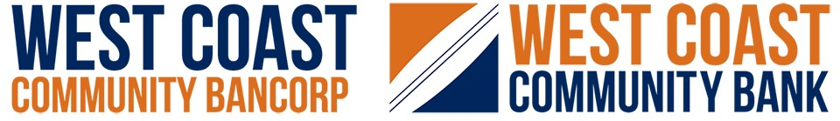
West Coast Community Bancorp Announces Listing on Nasdaq Stock Market

SANTA CRUZ, Calif., Sept. 15, 2026 (GLOBE NEWSWIRE) -- West Coast Community Bancorp (the “Company”) (Nasdaq: WCCB), the parent company of West Coast Community Bank, today announced that its Registration Statement on Form 10 has been declared effective by the U.S. Securities and Exchange Commission (“SEC”) and its common stock has been approved for listing on the Nasdaq Stock Market LLC (“Nasdaq”). The Company’s common stock, which previously traded on the OTCQX Best Market under the ticker symbol “WCCB,” is expected to begin trading on Nasdaq under the same ticker symbol at the opening of the market on September 16, 2026. Concurrently with the uplisting, the Company is launching an enhanced Investor Relations website at investors.wccb.com.

“Listing on Nasdaq marks an important milestone in West Coast Community Bancorp’s growth as a leading community banking franchise in California’s Central Coast and Silicon Valley,” said Krista Snelling, Chairman and Chief Executive Officer. “Our decision to uplist reflects the strength and maturity of our institution and our commitment to delivering long-term value for our shareholders. Access to one of the world’s most recognized and liquid equity markets positions us to deepen engagement with institutional investors and broaden our shareholder base as we continue executing on our strategic plan.”

Shareholders do not need to take any action in connection with the uplisting of the Company’s common stock. The Company is not issuing any new shares of common stock in connection with this listing. No proceeds are being raised as part of this process.

The Company's shares have traded publicly since 2004. Trading was previously conducted under the SCZC ticker symbol on OTC markets until the Bank was renamed West Coast Community Bank in 2025 and the ticker symbol was changed to WCCB. The shares subsequently traded on the OTCQX Best Market.

ABOUT WEST COAST COMMUNITY BANK AND WEST COAST COMMUNITY BANCORP

Founded in 2004, West Coast Community Bank is the wholly owned subsidiary of West Coast Community Bancorp, a bank holding company. The Bank is a top-rated, locally operated and full-service community bank headquartered in Santa Cruz, Calif. with branches in Aptos, Capitola, King City, Monterey, Salinas, San Jose, San Luis Obispo, Santa Cruz, Scotts Valley and Watsonville. West Coast Community Bank is distinguished from "big banks" by its relationship-based service, problem-solving focus and direct access to decision makers. The Bank also is an SBA Preferred Lending Partner. As a full-service bank, West Coast Community Bank offers competitive deposit and lending solutions for businesses and individuals; including business loans, lines of credit, commercial real estate financing, construction lending, asset-based lending, agricultural loans, SBA and USDA government guaranteed loans, credit cards, merchant services, remote deposit capture, mobile and online banking, bill payment and treasury management. True to its community roots, West Coast Community Bank supports regional well-being by actively participating in and donating to local nonprofit organizations. Visit wccb.com and investors.wccb.com for more information.

Additional information regarding the Company, including its most recent investor presentation, is available at the Company’s investors.wccb.com. Investors are encouraged to review these materials for additional information regarding the Company’s business, strategy, operations, and financial performance and condition. The Company’s most recent investor presentation has also been furnished with the SEC in connection with this release.

Forward-Looking Statements

This release contains forward-looking statements, including statements regarding the expected uplisting of the Company’s common stock to the Nasdaq Stock Market and the potential benefits of such listing. Words such as “believe,” “expect,” “estimate,” “project,” “forecast,” “anticipate,” “intend,” “plan,” “may,”
Exhibit 99.1

“will,” “could,” “should,” “predicts,” “continue” and similar expressions are intended to identify such forward-looking statements; however, the absence of these words does not mean the statements are not forward-looking. Forward-looking statements are based on current expectations, estimates and assumptions and are subject to risks and uncertainties that may cause actual results to differ materially from those expressed or implied by such statements. Factors that could cause actual results to differ include, but are not limited to, market conditions, the Company’s continued ability to satisfy Nasdaq listing requirements, regulatory developments, economic conditions, interest rate changes, and competitive pressures and other risks described in the Company’s filings with the U.S. Securities and Exchange Commission, including those discussed in the Company’s Registration Statement on Form 10. Any anticipated benefits of the uplisting of the Company’s common stock to the Nasdaq Stock Market are subject to market conditions and other factors outside of the Company’s control and no assurance can be given as to the effect that the uplisting may have on the price or trading volume of its common stock or on the liquidity of an investment in its common stock. Investors are cautioned not to place undue reliance on forward- looking statements, which speak only as of the date made. West Coast Community Bancorp undertakes no obligation to update forward-looking statements except as required by law.

MEDIA CONTACTS
Krista Snelling, Chairman and Chief Executive Officer
Cecilia Situ, Executive Vice President and Chief Financial Officer
investorrelations@wccb.com
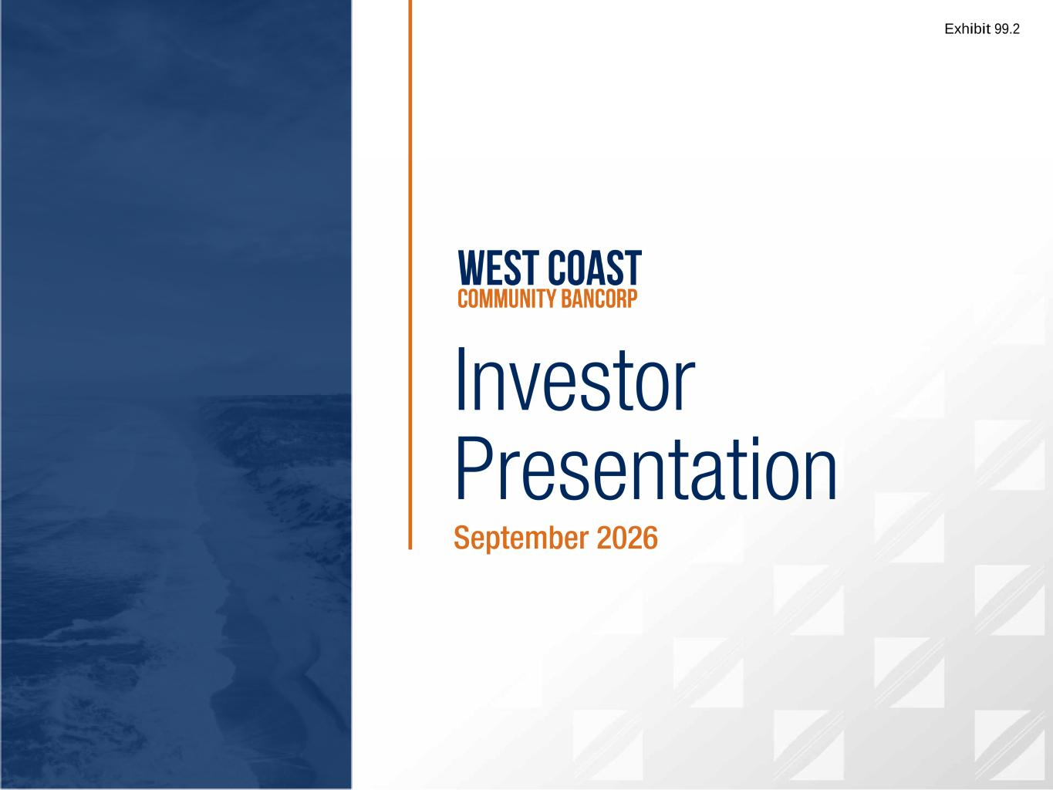

West Coast Community Bancorp Q2 2026 Investor Presentation | 1 Investor Presentation September 2026 Exhibit 99.2

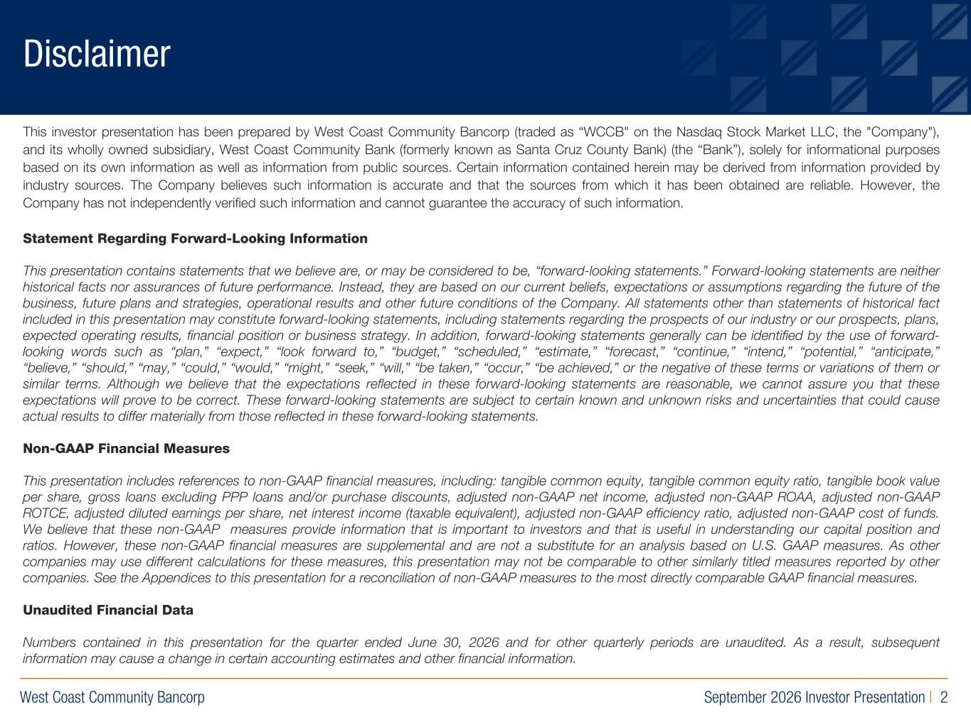
West Coast Community Bancorp September 2026 Investor Presentation | 2 R:219 G:109 B:29 R:0 G:40 B:93 R:155 G:154 B:163 This investor presentation has been prepared by West Coast Community Bancorp (traded as “WCCB" on the Nasdaq Stock Market LLC, the "Company"), and its wholly owned subsidiary, West Coast Community Bank (formerly known as Santa Cruz County Bank) (the “Bank”), solely for informational purposes based on its own information as well as information from public sources. Certain information contained herein may be derived from information provided by industry sources. The Company believes such information is accurate and that the sources from which it has been obtained are reliable. However, the Company has not independently verified such information and cannot guarantee the accuracy of such information. Statement Regarding Forward-Looking Information This presentation contains statements that we believe are, or may be considered to be, “forwardlooking statements.” Forwardlooking statements are neither historical facts nor assurances of future performance. Instead, they are based on our current beliefs, expectations or assumptions regarding the future of the business, future plans and strategies, operational results and other future conditions of the Company. All statements other than statements of historical fact included in this presentation may constitute forwardlooking statements, including statements regarding the prospects of our industry or our prospects, plans, expected operating results, financial position or business strategy. In addition, forwardlooking statements generally can be identified by the use of forward looking words such as “plan,” “expect,” “look forward to,” “budget,” “scheduled,” “estimate,” “forecast,” “continue,” “intend,” “potential,” “anticipate,” “believe,” “should,” “may,” “could,” “would,” “might,” “seek,” “will,” “be taken,” “occur,” “be achieved,” or the negative of these terms or variations of them or similar terms. Although we believe that the expectations reflected in these forwardlooking statements are reasonable, we cannot assure you that these expectations will prove to be correct. These forwardlooking statements are subject to certain known and unknown risks and uncertainties that could cause actual results to differ materially from those reflected in these forwardlooking statements. Non-GAAP Financial Measures This presentation includes references to nonGAAP financial measures, including: tangible common equity, tangible common equity ratio, tangible book value per share, gross loans excluding PPP loans and/or purchase discounts, adjusted nonGAAP net income, adjusted nonGAAP ROAA, adjusted nonGAAP ROTCE, adjusted diluted earnings per share, net interest income (taxable equivalent), adjusted nonGAAP efficiency ratio, adjusted nonGAAP cost of funds. We believe that these nonGAAP measures provide information that is important to investors and that is useful in understanding our capital position and ratios. However, these nonGAAP financial measures are supplemental and are not a substitute for an analysis based on U.S. GAAP measures. As other companies may use different calculations for these measures, this presentation may not be comparable to other similarly titled measures reported by other companies. See the Appendices to this presentation for a reconciliation of nonGAAP measures to the most directly comparable GAAP financial measures. Unaudited Financial Data Numbers contained in this presentation for the quarter ended June 30, 2026 and for other quarterly periods are unaudited. As a result, subsequent information may cause a change in certain accounting estimates and other financial information. Disclaimer

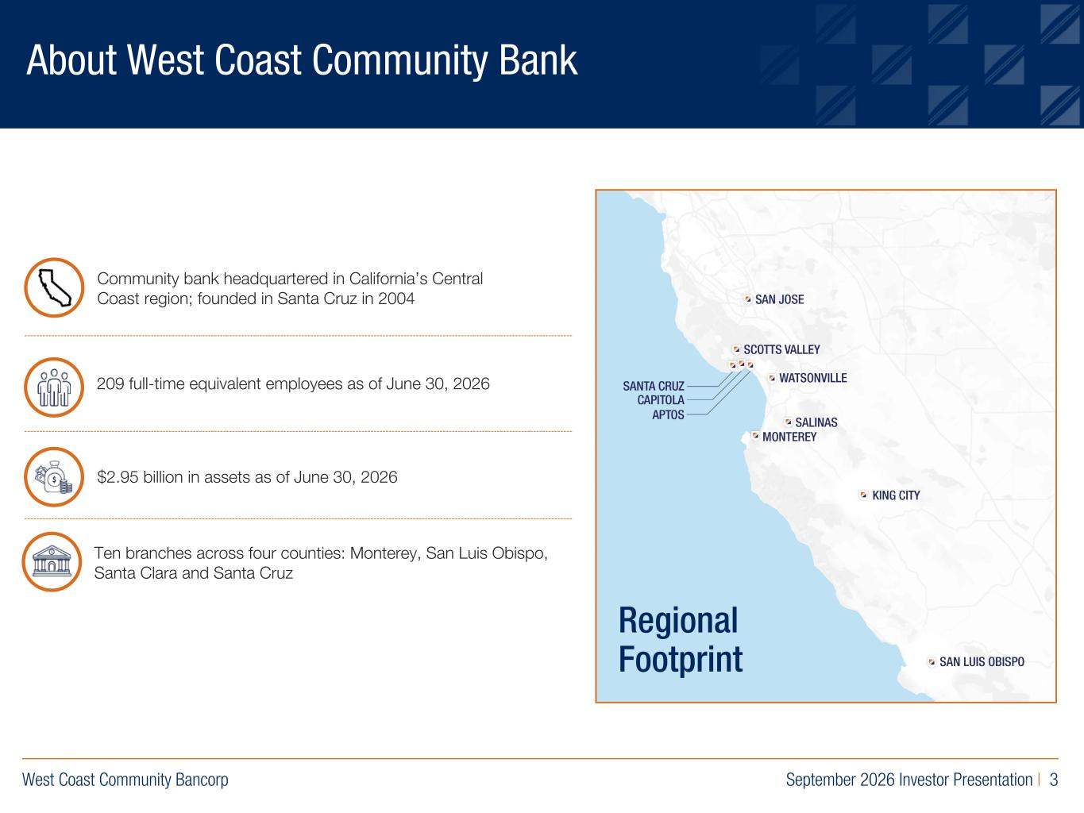
West Coast Community Bancorp September 2026 Investor Presentation | 3 R:219 G:109 B:29 R:0 G:40 B:93 R:155 G:154 B:163 About West Coast Community Bank 209 full-time equivalent employees as of June 30, 2026 $2.95 billion in assets as of June 30, 2026 Community bank headquartered in California’s Central Coast region; founded in Santa Cruz in 2004 Regional Footprint Ten branches across four counties: Monterey, San Luis Obispo, Santa Clara and Santa Cruz

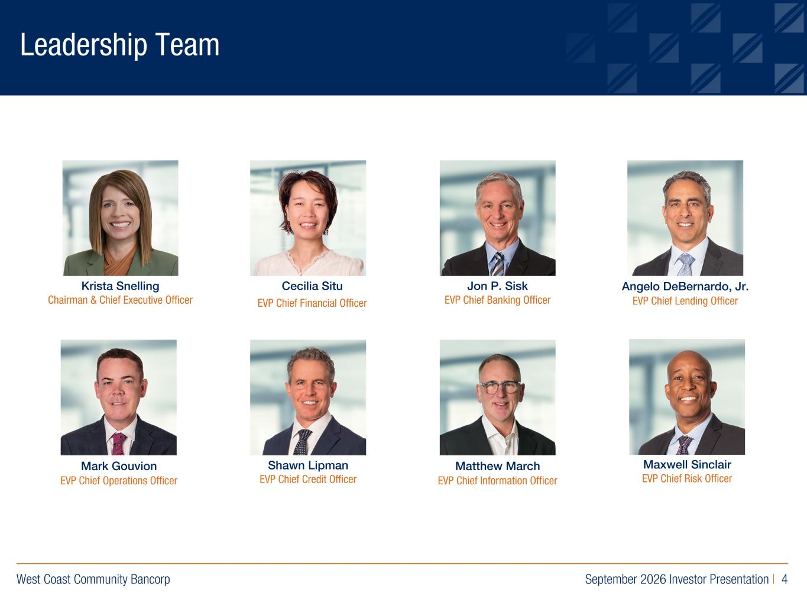
West Coast Community Bancorp September 2026 Investor Presentation | 4 R:219 G:109 B:29 R:0 G:40 B:93 R:155 G:154 B:163 Leadership Team Krista Snelling Chairman & Chief Executive Officer Angelo DeBernardo, Jr. EVP Chief Lending Officer Jon P. Sisk EVP Chief Banking Officer Shawn Lipman EVP Chief Credit Officer Maxwell Sinclair EVP Chief Risk Officer Mark Gouvion EVP Chief Operations Officer Cecilia Situ EVP Chief Financial Officer Matthew March EVP Chief Information Officer

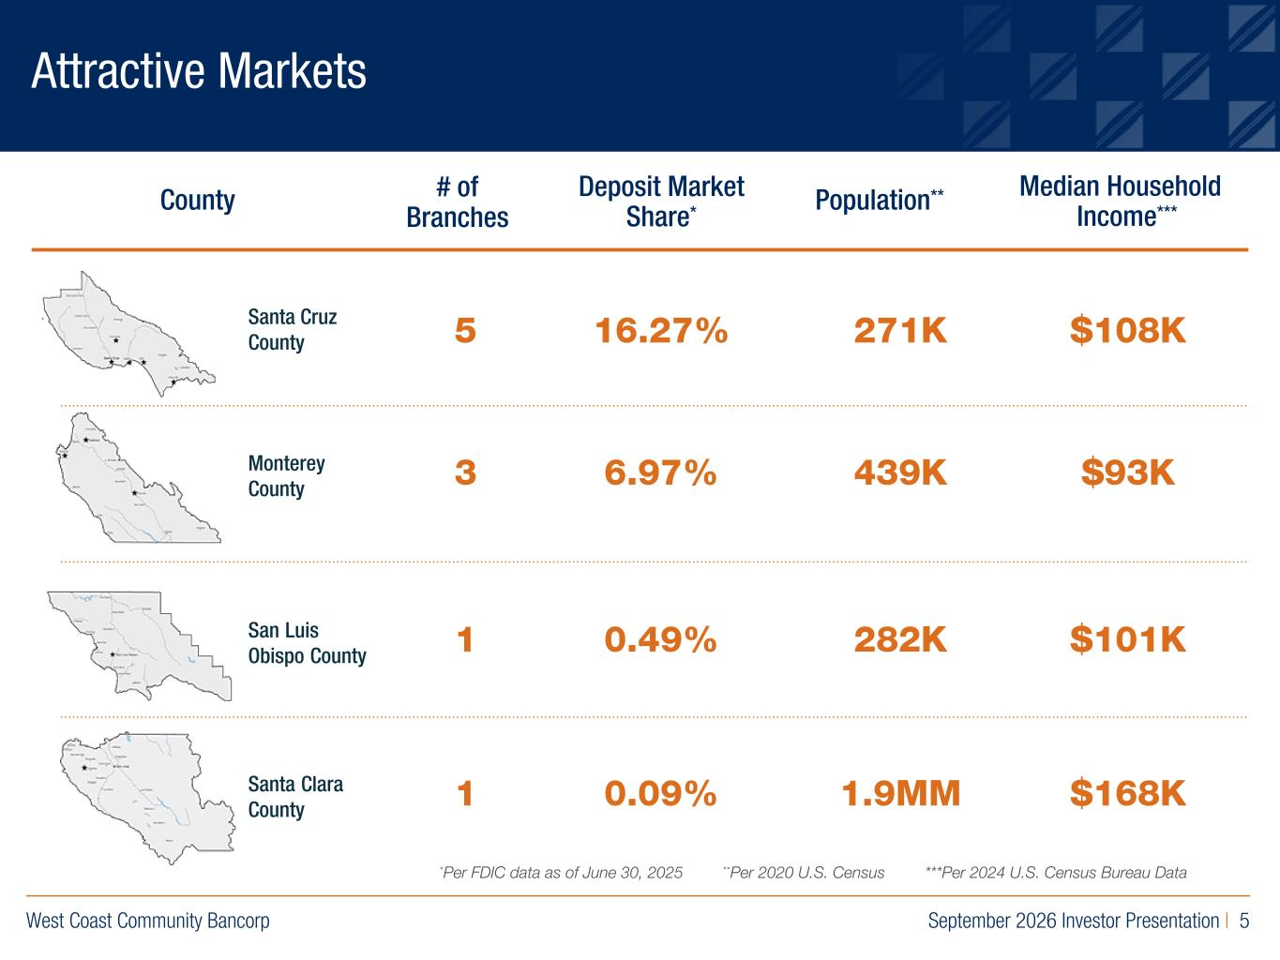
West Coast Community Bancorp September 2026 Investor Presentation | 5 R:219 G:109 B:29 R:0 G:40 B:93 R:155 G:154 B:163 Attractive Markets Monterey County County # of Branches Deposit Market Share* Median Household Income***Population** 5 16.27% 3 6.97% 1 0.49% 1 0.09% 271K 439K 282K 1.9MM $108K $93K $101K $168K *Per FDIC data as of June 30, 2025 **Per 2020 U.S. Census ***Per 2024 U.S. Census Bureau Data Santa Cruz County San Luis Obispo County Santa Clara County

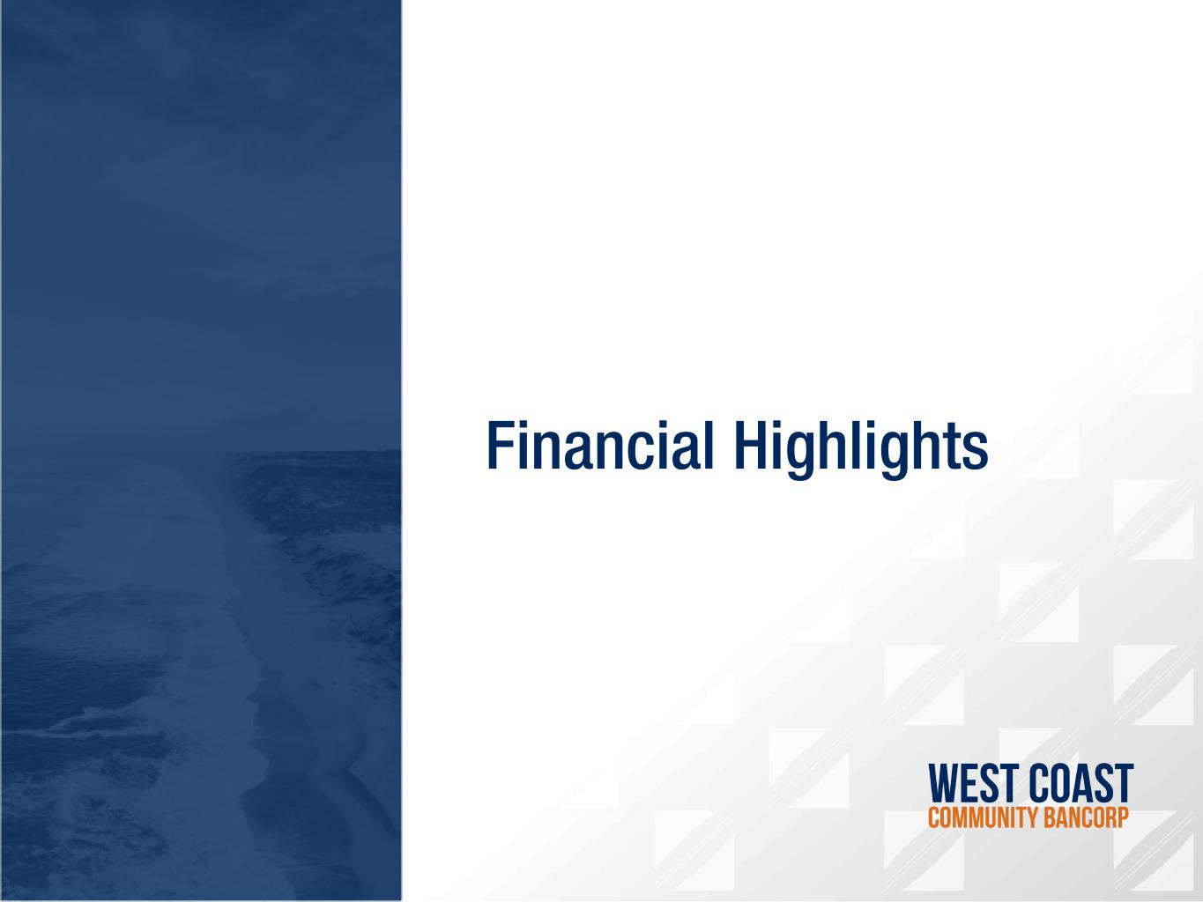
R:219 G:109 B:29 R:0 G:40 B:93 R:155 G:154 B:163 Financial Highlights

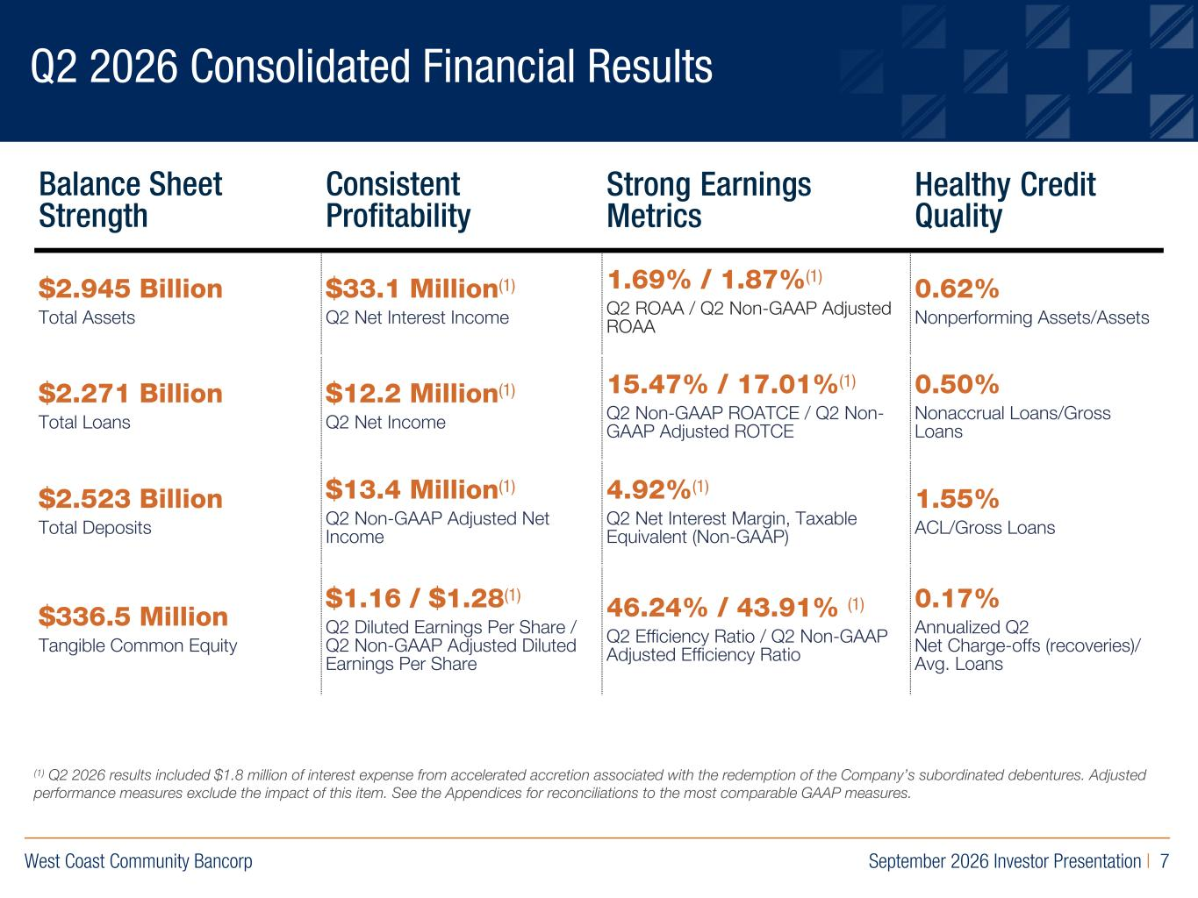
West Coast Community Bancorp September 2026 Investor Presentation | 7 R:219 G:109 B:29 R:0 G:40 B:93 R:155 G:154 B:163 Q2 2026 Consolidated Financial Results Balance Sheet Strength Consistent Profitability Strong Earnings Metrics Healthy Credit Quality $2.945 Billion Total Assets $33.1 Million(1) Q2 Net Interest Income 1.69% / 1.87%(1) Q2 ROAA / Q2 Non-GAAP Adjusted ROAA 0.62% Nonperforming Assets/Assets $2.271 Billion Total Loans $12.2 Million(1) Q2 Net Income 15.47% / 17.01%(1) Q2 Non-GAAP ROATCE / Q2 Non- GAAP Adjusted ROTCE 0.50% Nonaccrual Loans/Gross Loans $2.523 Billion Total Deposits $13.4 Million(1) Q2 Non-GAAP Adjusted Net Income 4.92%(1) Q2 Net Interest Margin, Taxable Equivalent (Non-GAAP) 1.55% ACL/Gross Loans $336.5 Million Tangible Common Equity $1.16 / $1.28(1) Q2 Diluted Earnings Per Share / Q2 Non-GAAP Adjusted Diluted Earnings Per Share 46.24% / 43.91% (1) Q2 Efficiency Ratio / Q2 Non-GAAP Adjusted Efficiency Ratio 0.17% Annualized Q2 Net Charge-offs (recoveries)/ Avg. Loans (1) Q2 2026 results included $1.8 million of interest expense from accelerated accretion associated with the redemption of the Company’s subordinated debentures. Adjusted performance measures exclude the impact of this item. See the Appendices for reconciliations to the most comparable GAAP measures.

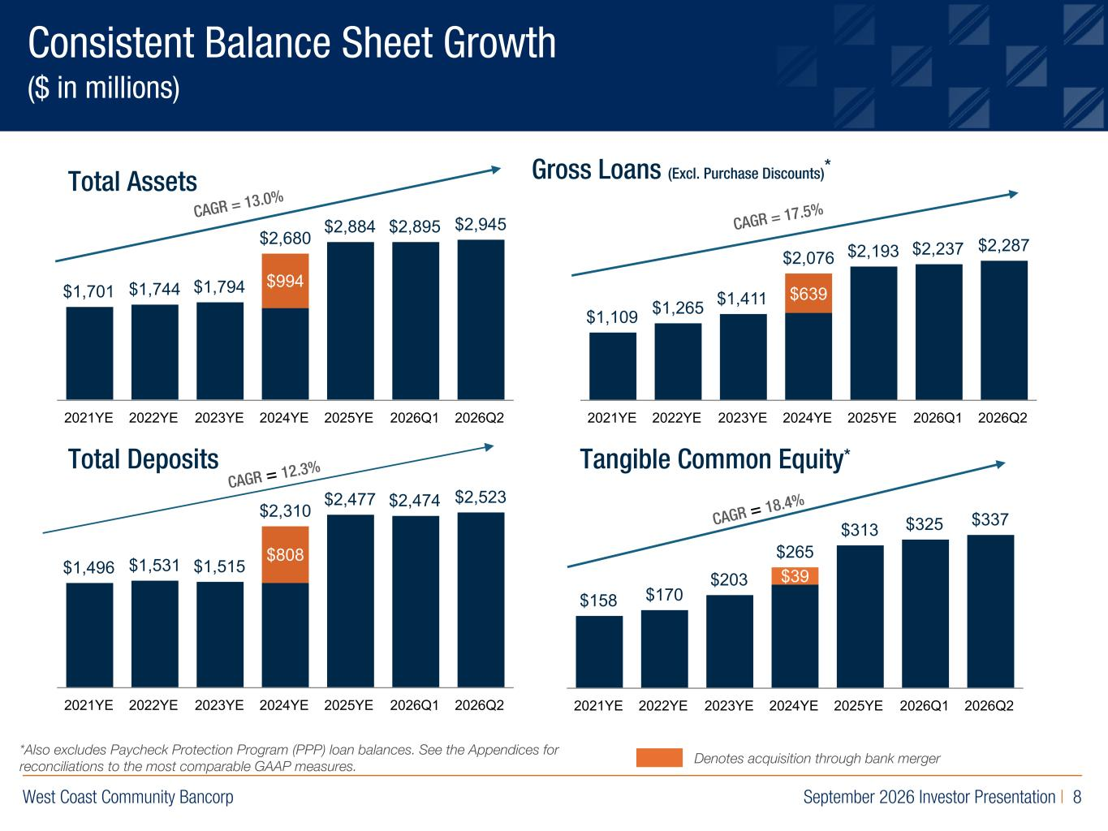
West Coast Community Bancorp September 2026 Investor Presentation | 8 R:219 G:109 B:29 R:0 G:40 B:93 R:155 G:154 B:163 Consistent Balance Sheet Growth ($ in millions) Total Assets Gross Loans (Excl. Purchase Discounts)* Total Deposits Tangible Common Equity* *Also excludes Paycheck Protection Program (PPP) loan balances. See the Appendices for reconciliations to the most comparable GAAP measures. Denotes acquisition through bank merger $1,701 $1,744 $1,794 $2,680 $2,884 $2,895 $2,945 $994 2021YE 2022YE 2023YE 2024YE 2025YE 2026Q1 2026Q2 $1,109 $1,265 $1,411 $2,076 $2,193 $2,237 $2,287 $639 2021YE 2022YE 2023YE 2024YE 2025YE 2026Q1 2026Q2 $1,496 $1,531 $1,515 $2,310 $2,477 $2,474 $2,523 $808 2021YE 2022YE 2023YE 2024YE 2025YE 2026Q1 2026Q2 $158 $170 $203 $265 $313 $325 $337 $39 2021YE 2022YE 2023YE 2024YE 2025YE 2026Q1 2026Q2 CAGR = 13.0% CAGR = 17.5% CAGR = 12.3% CAGR = 18.4%

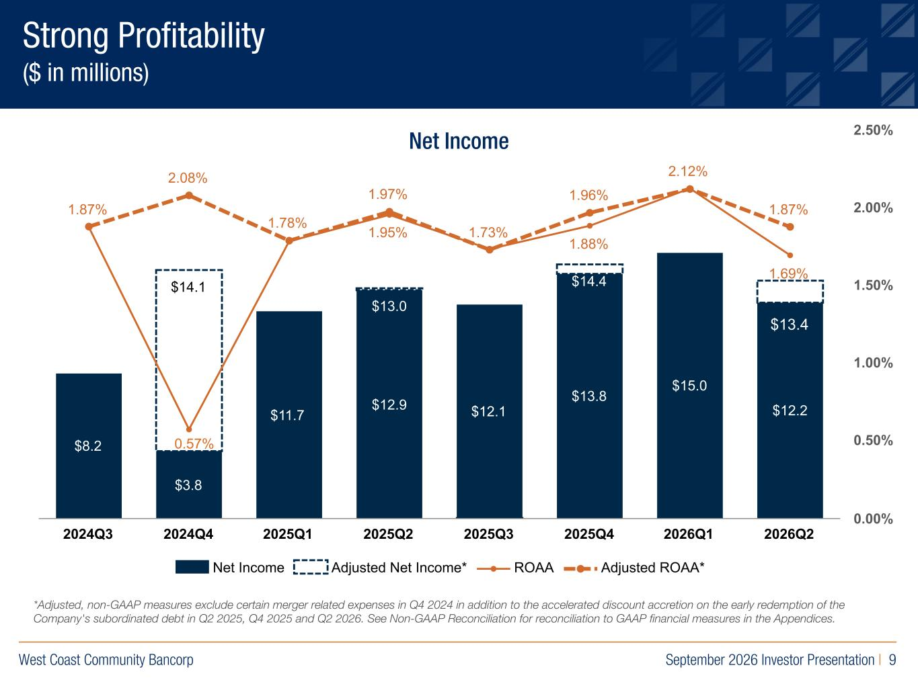
West Coast Community Bancorp September 2026 Investor Presentation | 9 R:219 G:109 B:29 R:0 G:40 B:93 R:155 G:154 B:163 Strong Profitability ($ in millions) *Adjusted, nonGAAP measures exclude certain merger related expenses in Q4 2024 in addition to the accelerated discount accretion on the early redemption of the Company's subordinated debt in Q2 2025, Q4 2025 and Q2 2026. See NonGAAP Reconciliation for reconciliation to GAAP financial measures in the Appendices. Net Income $8.2 $3.8 $11.7 $12.9 $12.1 $13.8 $15.0 $12.2 1.95% 1.88% 1.69% 1.87% 2.08% 1.78% 1.97% 1.73% 1.96% 2.12% 1.87% $14.1 $13.0 $14.4 Net Income Adjusted Net Income* ROAA Adjusted ROAA* 2024Q3 2024Q4 2025Q1 2025Q2 2025Q3 2025Q4 2026Q1 2026Q2 0.00% 0.50% 1.00% 1.50% 2.00% 2.50% $13.4 0.57%

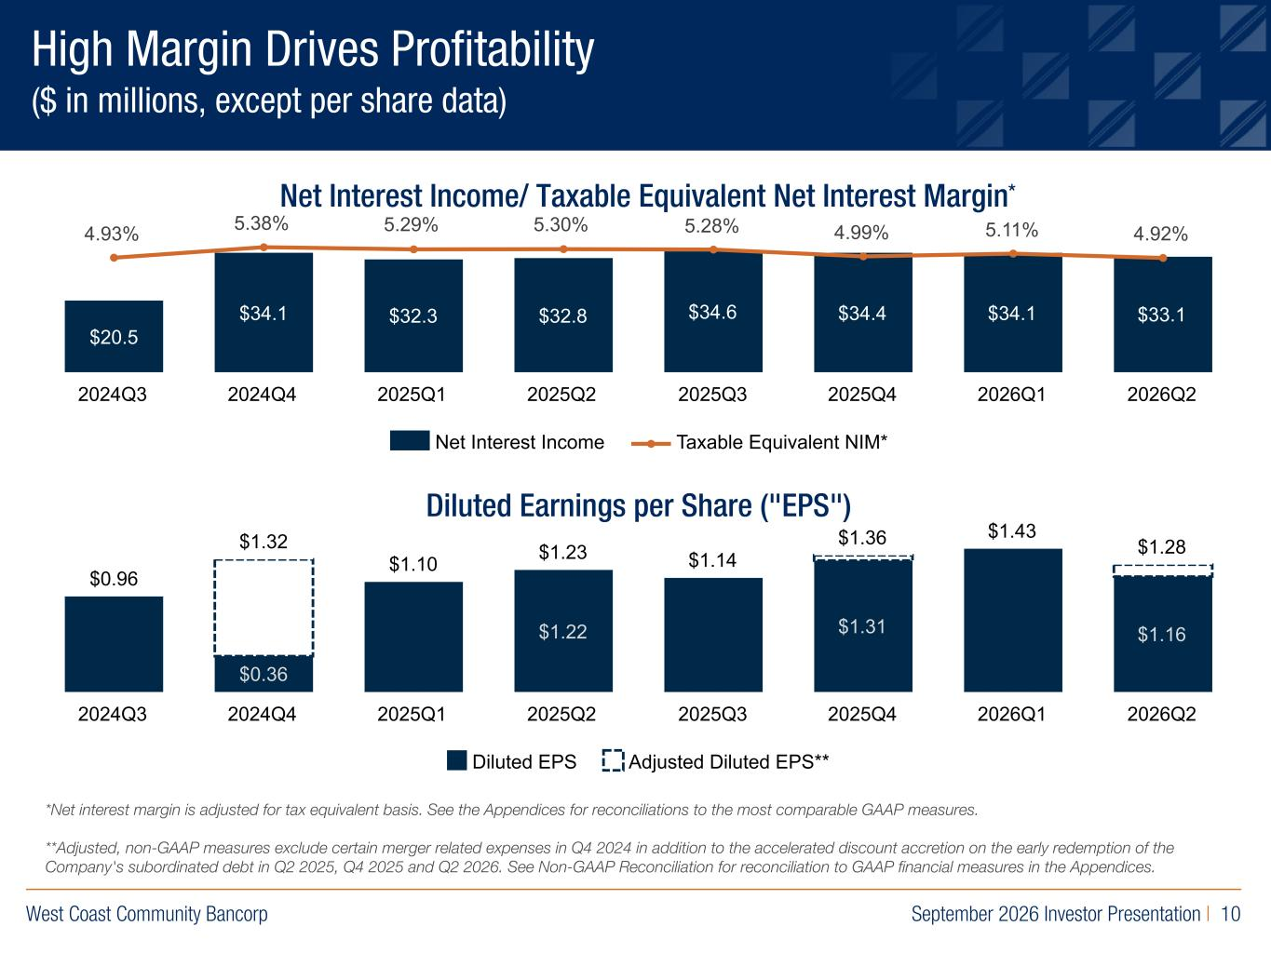
West Coast Community Bancorp September 2026 Investor Presentation | 10 R:219 G:109 B:29 R:0 G:40 B:93 R:155 G:154 B:163 *Net interest margin is adjusted for tax equivalent basis. See the Appendices for reconciliations to the most comparable GAAP measures. **Adjusted, nonGAAP measures exclude certain merger related expenses in Q4 2024 in addition to the accelerated discount accretion on the early redemption of the Company's subordinated debt in Q2 2025, Q4 2025 and Q2 2026. See NonGAAP Reconciliation for reconciliation to GAAP financial measures in the Appendices. High Margin Drives Profitability ($ in millions, except per share data) Net Interest Income/ Taxable Equivalent Net Interest Margin* Diluted Earnings per Share ("EPS") $20.5 $34.1 $32.3 $32.8 $34.6 $34.4 $34.1 $33.1 4.93% 5.38% 5.29% 5.30% 5.28% 4.99% 5.11% 4.92% Net Interest Income Taxable Equivalent NIM* 2024Q3 2024Q4 2025Q1 2025Q2 2025Q3 2025Q4 2026Q1 2026Q2 $0.36 $1.22 $1.31 $1.16 $0.96 $1.32 $1.10 $1.23 $1.14 $1.36 $1.43 $1.28 Diluted EPS Adjusted Diluted EPS** 2024Q3 2024Q4 2025Q1 2025Q2 2025Q3 2025Q4 2026Q1 2026Q2

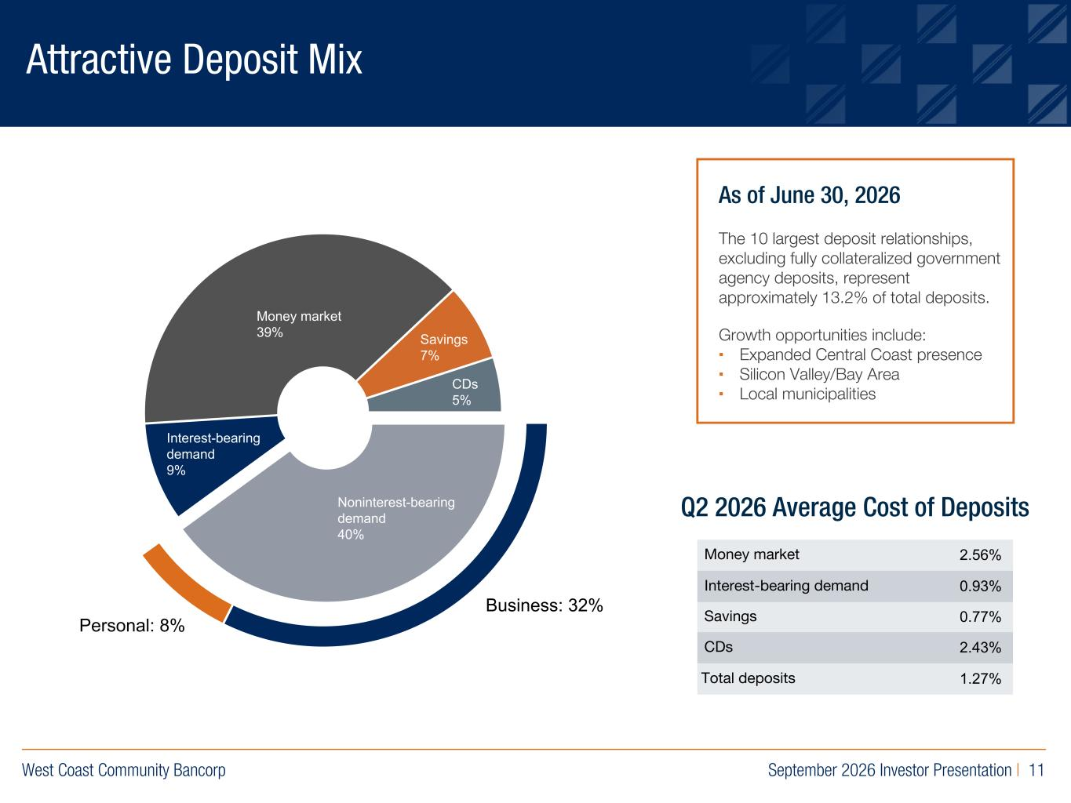
West Coast Community Bancorp September 2026 Investor Presentation | 11 R:219 G:109 B:29 R:0 G:40 B:93 R:155 G:154 B:163 Attractive Deposit Mix As of June 30, 2026 The 10 largest deposit relationships, excluding fully collateralized government agency deposits, represent approximately 13.2% of total deposits. Growth opportunities include: ▪ Expanded Central Coast presence ▪ Silicon Valley/Bay Area ▪ Local municipalities Money market 2.56% Interest-bearing demand 0.93% Savings 0.77% CDs 2.43% Total deposits 1.27% Q2 2026 Average Cost of DepositsNoninterest-bearing demand 40% Interest-bearing demand 9% Money market 39% Savings 7% CDs 5% Business: 32% Personal: 8%

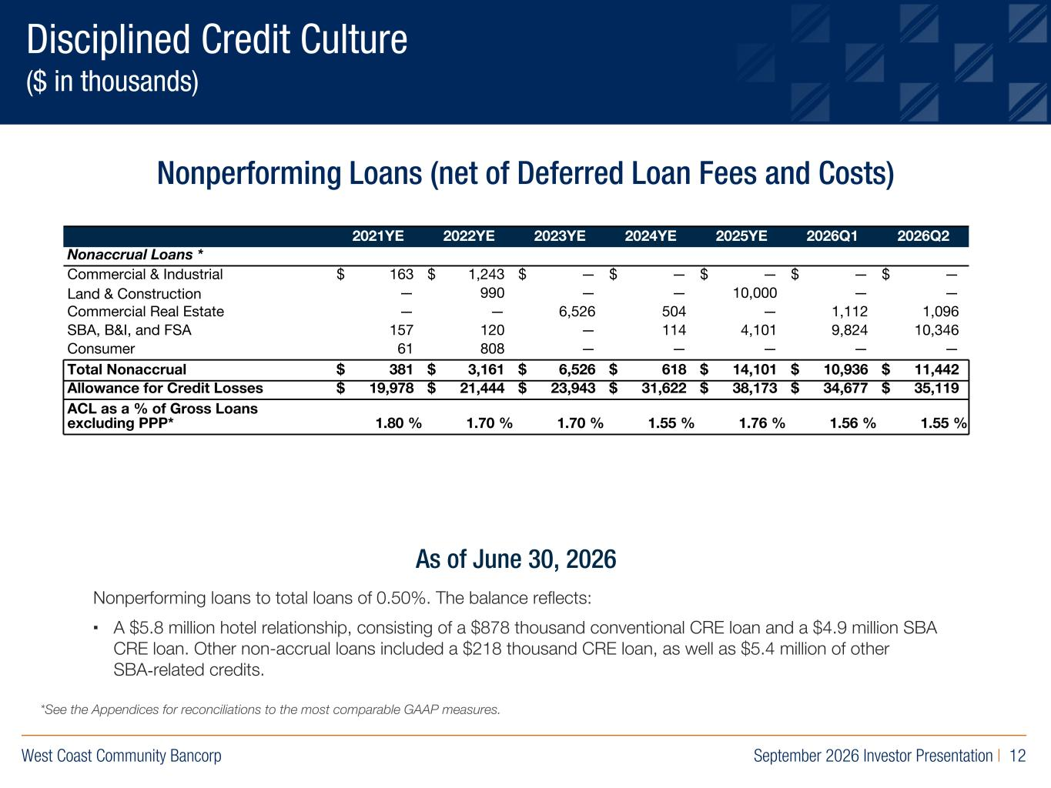
West Coast Community Bancorp September 2026 Investor Presentation | 12 R:219 G:109 B:29 R:0 G:40 B:93 R:155 G:154 B:163 Disciplined Credit Culture ($ in thousands) Nonperforming Loans (net of Deferred Loan Fees and Costs) Nonperforming loans to total loans of 0.50%. The balance reflects: ▪ A $5.8 million hotel relationship, consisting of a $878 thousand conventional CRE loan and a $4.9 million SBA CRE loan. Other non-accrual loans included a $218 thousand CRE loan, as well as $5.4 million of other SBA-related credits. As of June 30, 2026 2021YE 2022YE 2023YE 2024YE 2025YE 2026Q1 2026Q2 Nonaccrual Loans * Commercial & Industrial $ 163 $ 1,243 $ — $ — $ — $ — $ — Land & Construction — 990 — — 10,000 — — Commercial Real Estate — — 6,526 504 — 1,112 1,096 SBA, B&I, and FSA 157 120 — 114 4,101 9,824 10,346 Consumer 61 808 — — — — — Total Nonaccrual $ 381 $ 3,161 $ 6,526 $ 618 $ 14,101 $ 10,936 $ 11,442 Allowance for Credit Losses $ 19,978 $ 21,444 $ 23,943 $ 31,622 $ 38,173 $ 34,677 $ 35,119 ACL as a % of Gross Loans excluding PPP* 1.80 % 1.70 % 1.70 % 1.55 % 1.76 % 1.56 % 1.55 % *See the Appendices for reconciliations to the most comparable GAAP measures.

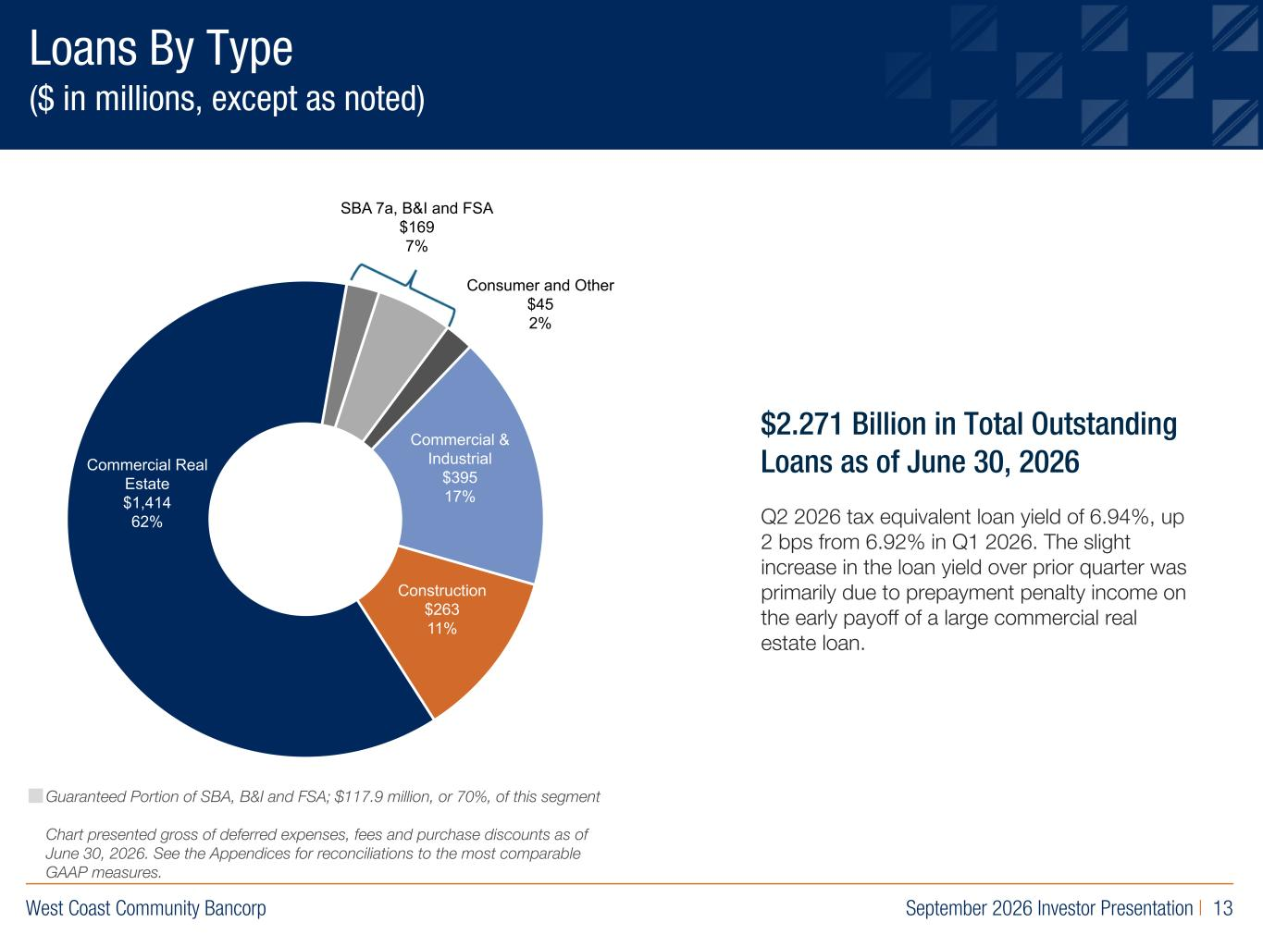
West Coast Community Bancorp September 2026 Investor Presentation | 13 R:219 G:109 B:29 R:0 G:40 B:93 R:155 G:154 B:163 Loans By Type ($ in millions, except as noted) Commercial Real Estate $1,352 62% Commercial & Industrial $366 17% Construction $254 12% Guaranteed Portion of SBA, B&I and FSA; $117.9 million, or 70%, of this segment Chart presented gross of deferred expenses, fees and purchase discounts as of June 30, 2026. See the Appendices for reconciliations to the most comparable GAAP measures. $2.271 Billion in Total Outstanding Loans as of June 30, 2026 Q2 2026 tax equivalent loan yield of 6.94%, up 2 bps from 6.92% in Q1 2026. The slight increase in the loan yield over prior quarter was primarily due to prepayment penalty income on the early payoff of a large commercial real estate loan. Commercial Real Estate $1,414 62% Construction 63 1 Co ercial & In i l 95 17 Consumer and Other $45 2% SBA 7a, B&I and FSA $169 7%

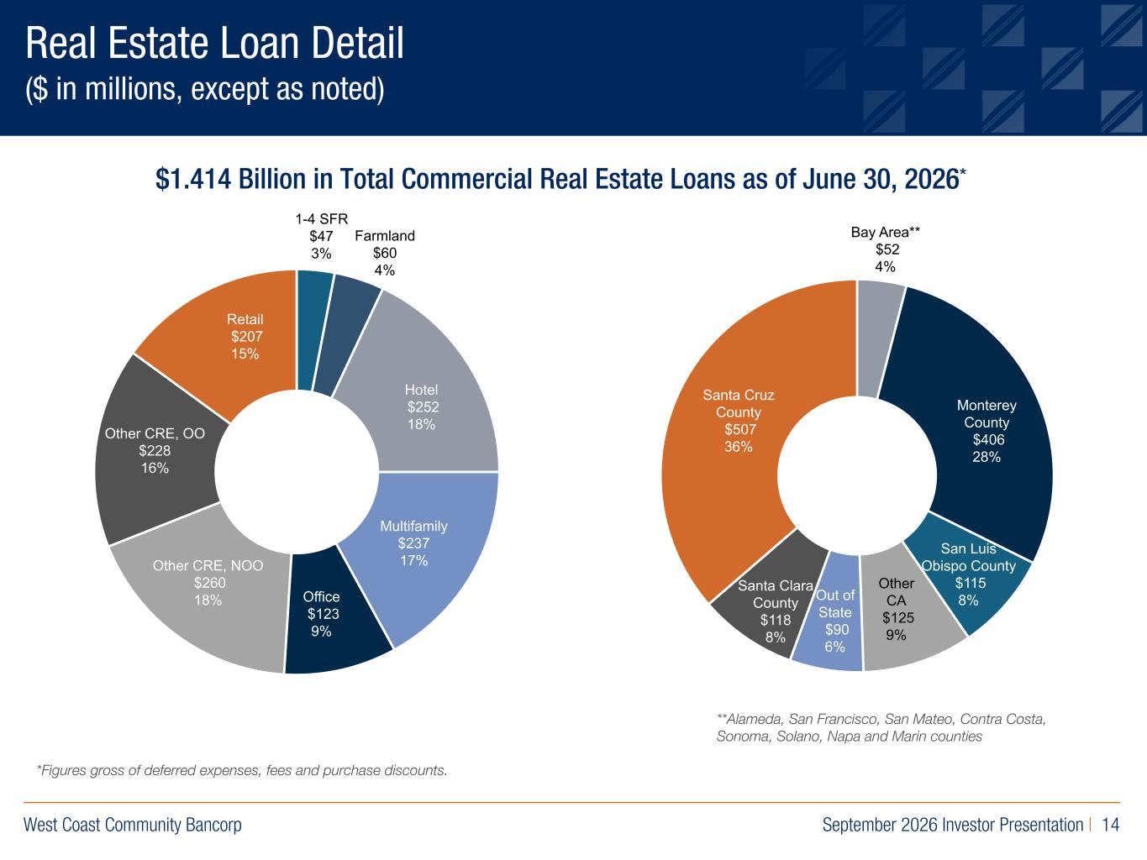
West Coast Community Bancorp September 2026 Investor Presentation | 14 R:219 G:109 B:29 R:0 G:40 B:93 R:155 G:154 B:163 Real Estate Loan Detail ($ in millions, except as noted) $1.414 Billion in Total Commercial Real Estate Loans as of June 30, 2026* **Alameda, San Francisco, San Mateo, Contra Costa, Sonoma, Solano, Napa and Marin counties *Figures gross of deferred expenses, fees and purchase discounts. Retail $157 12% Other CRE, OO $233 17% Office $128 9% Hotel $238 18% Multifamily $240 18% Monterey County $416 31% Santa Cruz County $496 36% Santa Clara County $129 10% Hotel $237 18% 1-4 SFR $47 3% Farmland $60 4% Hotel $252 18% Multifamily $237 17% Office $123 9% Other CRE, NOO $260 18% Other CRE, OO $228 16% Retail $207 15% Bay Area** $52 4% Santa Cruz County $507 36% Mont rey County $406 28% San Luis Obispo County $115 8% Other CA $125 9% Out of State $90 6% Santa Clara County $118 8%

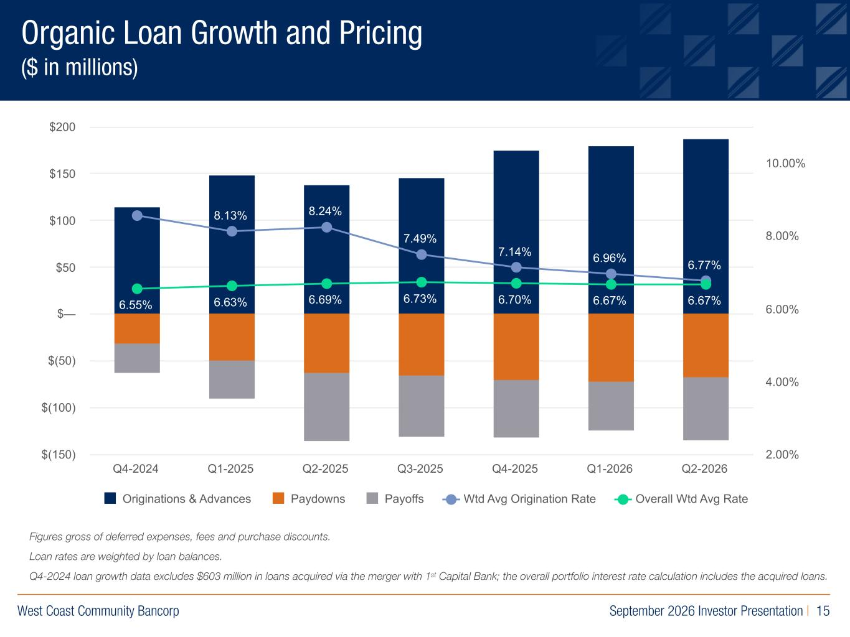
West Coast Community Bancorp September 2026 Investor Presentation | 15 R:219 G:109 B:29 R:0 G:40 B:93 R:155 G:154 B:163 Organic Loan Growth and Pricing ($ in millions) Figures gross of deferred expenses, fees and purchase discounts. Loan rates are weighted by loan balances. Q42024 loan growth data excludes $603 million in loans acquired via the merger with 1st Capital Bank; the overall portfolio interest rate calculation includes the acquired loans. 8.56% 8.13% 8.24% 7.49% 7.14% 6.96% 6.77% 6.55% 6.63% 6.69% 6.73% 6.70% 6.67% 6.67% Originations & Advances Paydowns Payoffs Wtd Avg Origination Rate Overall Wtd Avg Rate Q4-2024 Q1-2025 Q2-2025 Q3-2025 Q4-2025 Q1-2026 Q2-2026 $(150) $(100) $(50) $— $50 $100 $150 $200 2.00% 4.00% 6.00% 8.00% 10.00%

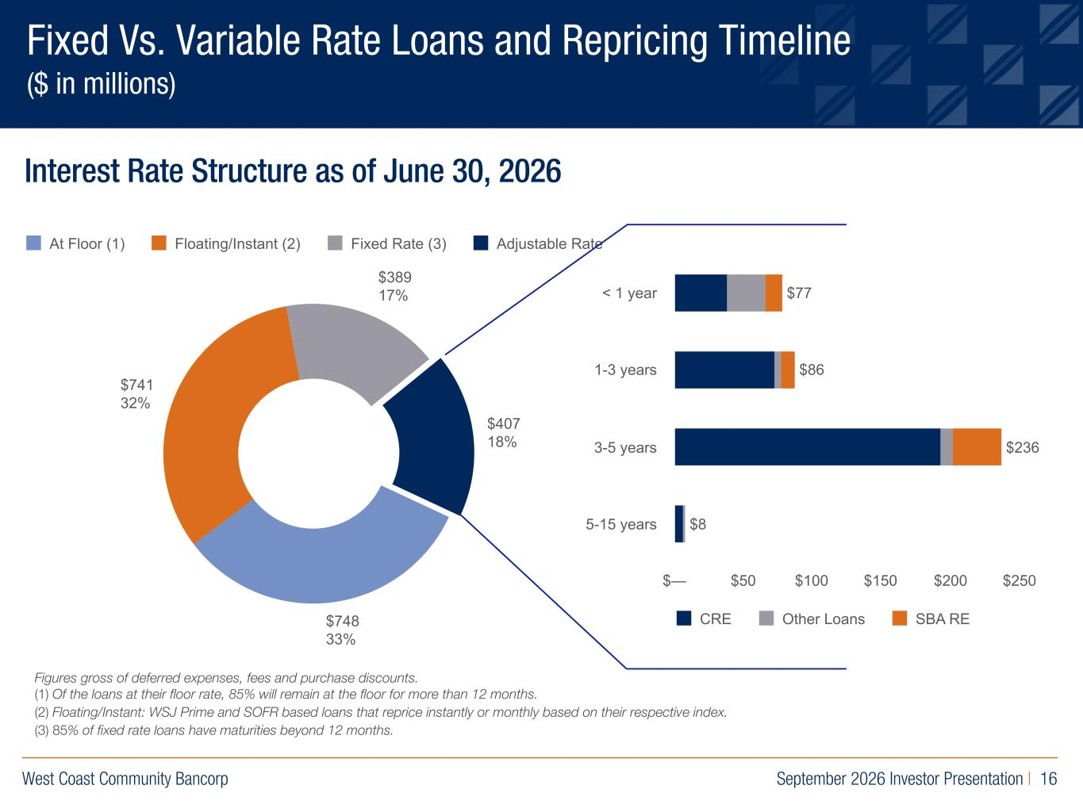
West Coast Community Bancorp September 2026 Investor Presentation | 16 R:219 G:109 B:29 R:0 G:40 B:93 R:155 G:154 B:163 Fixed Vs. Variable Rate Loans and Repricing Timeline ($ in millions) Figures gross of deferred expenses, fees and purchase discounts. (1) Of the loans at their floor rate, 85% will remain at the floor for more than 12 months. (2) Floating/Instant: WSJ Prime and SOFR based loans that reprice instantly or monthly based on their respective index. (3) 85% of fixed rate loans have maturities beyond 12 months. Interest Rate Structure as of June 30, 2026 $748 33% $741 32% $389 17% $407 18% At Floor (1) Floating/Instant (2) Fixed Rate (3) Adjustable Rate $77 $86 $236 $8 CRE Other Loans SBA RE $— $50 $100 $150 $200 $250 < 1 year 1-3 years 3-5 years 5-15 years

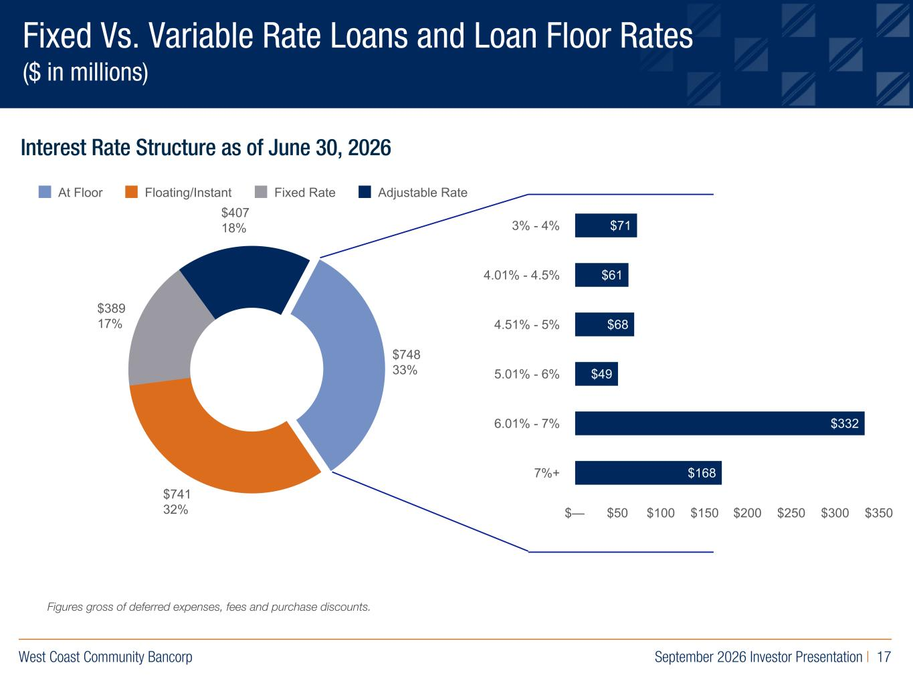
West Coast Community Bancorp September 2026 Investor Presentation | 17 R:219 G:109 B:29 R:0 G:40 B:93 R:155 G:154 B:163 Fixed Vs. Variable Rate Loans and Loan Floor Rates ($ in millions) Interest Rate Structure as of June 30, 2026 $748 33% $741 32% $389 17% $407 18% At Floor Floating/Instant Fixed Rate Adjustable Rate $71 $61 $68 $49 $332 $168 $— $50 $100 $150 $200 $250 $300 $350 3% - 4% 4.01% - 4.5% 4.51% - 5% 5.01% - 6% 6.01% - 7% 7%+ Figures gross of deferred expenses, fees and purchase discounts.

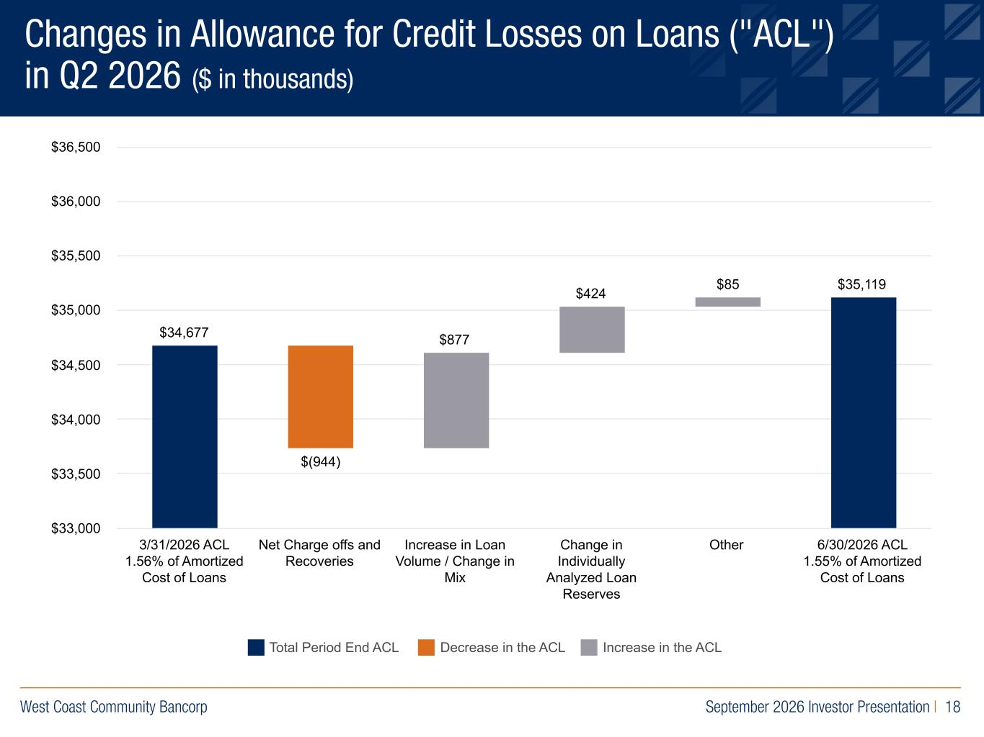
West Coast Community Bancorp September 2026 Investor Presentation | 18 R:219 G:109 B:29 R:0 G:40 B:93 R:155 G:154 B:163 Changes in Allowance for Credit Losses on Loans ("ACL") in Q2 2026 ($ in thousands) Total Period End ACL Decrease in the ACL Increase in the ACL $34,677 $(944) $877 $424 $85 $35,119 3/31/2026 ACL 1.56% of Amortized Cost of Loans Net Charge offs and Recoveries Increase in Loan Volume / Change in Mix Change in Individually Analyzed Loan Reserves Other 6/30/2026 ACL 1.55% of Amortized Cost of Loans $33,000 $33,500 $34,000 $34,500 $35,000 $35,500 $36,000 $36,500

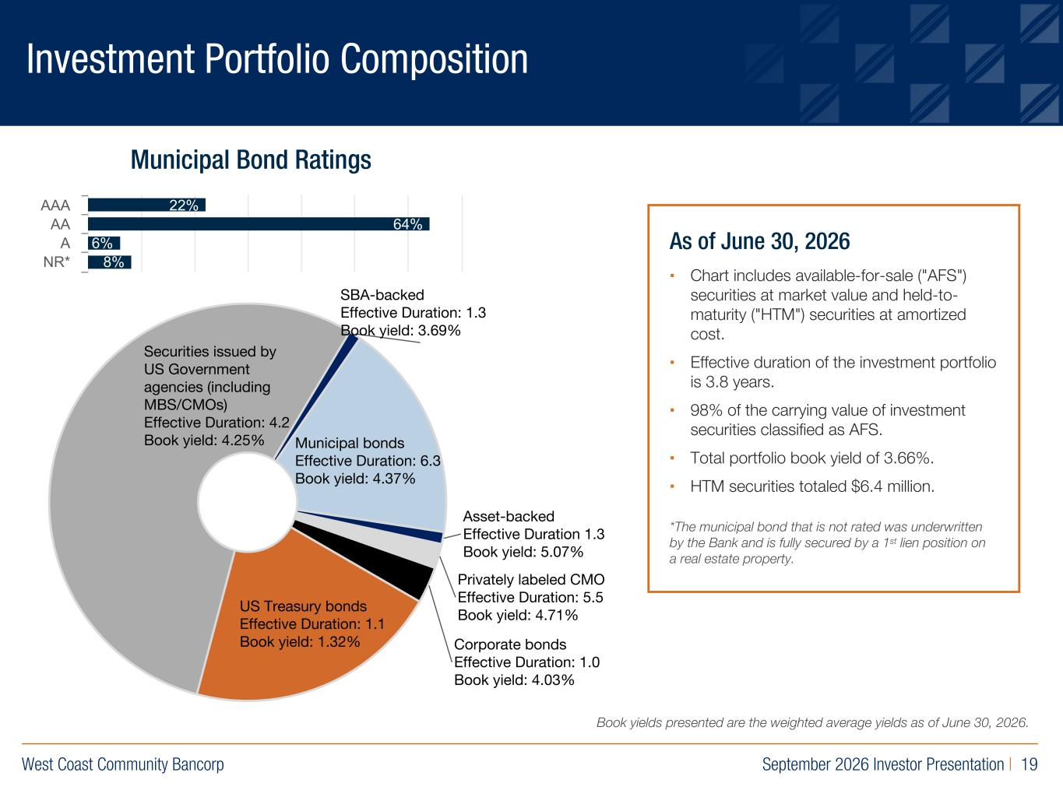
West Coast Community Bancorp September 2026 Investor Presentation | 19 R:219 G:109 B:29 R:0 G:40 B:93 R:155 G:154 B:163 Investment Portfolio Composition As of June 30, 2026 ▪ Chart includes available-for-sale ("AFS") securities at market value and held-to- maturity ("HTM") securities at amortized cost. ▪ Effective duration of the investment portfolio is 3.8 years. ▪ 98% of the carrying value of investment securities classified as AFS. ▪ Total portfolio book yield of 3.66%. ▪ HTM securities totaled $6.4 million. *The municipal bond that is not rated was underwritten by the Bank and is fully secured by a 1st lien position on a real estate property. Municipal Bond Ratings 22% 64% 6% 8% AAA AA A NR* US Treasury bonds Effective Duration: 1.1 Book yield: 1.32% Securities issued by US Government agencies (including MBS/CMOs) Effective Duration: 4.2 Book yield: 4.25% SBAbacked Effective Duration: 1.3 Book yield: 3.69% Municipal bonds Effective Duration: 6.3 Book yield: 4.37% Assetbacked Effective Duration 1.3 Book yield: 5.07% Privately labeled CMO Effective Duration: 5.5 Book yield: 4.71% Corporate bonds Effective Duration: 1.0 Book yield: 4.03% Book yields presented are the weighted average yields as of June 30, 2026.

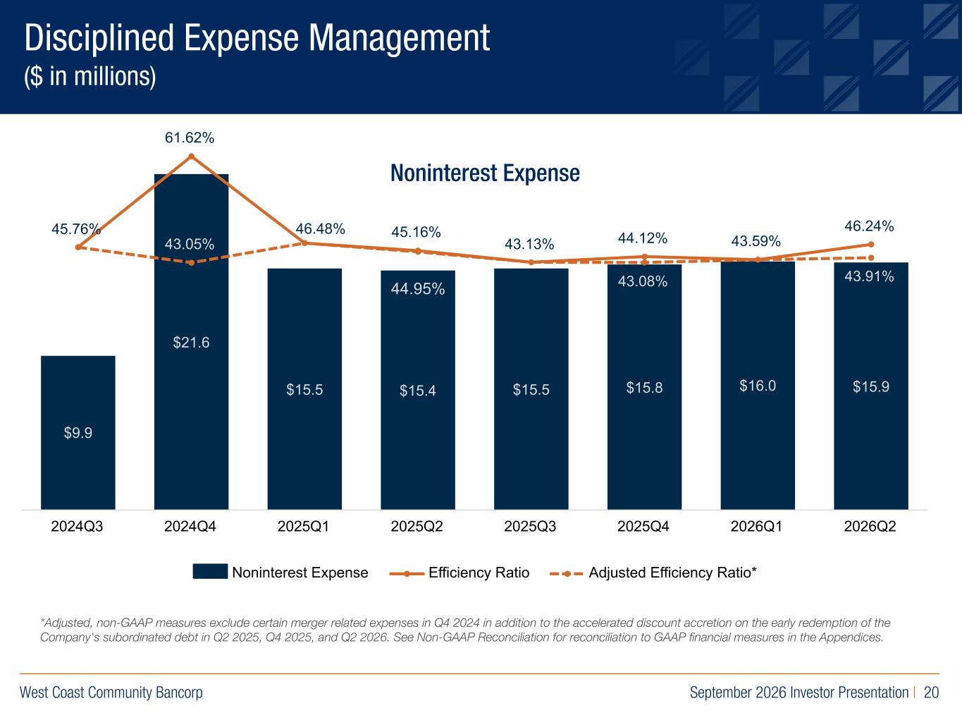
West Coast Community Bancorp September 2026 Investor Presentation | 20 R:219 G:109 B:29 R:0 G:40 B:93 R:155 G:154 B:163 $9.9 $21.6 $15.5 $15.4 $15.5 $15.8 $16.0 $15.9 45.76% 61.62% 45.16% 43.13% 44.12% 43.59% 46.24% 43.05% 43.08% 43.91% Noninterest Expense Efficiency Ratio Adjusted Efficiency Ratio* 2024Q3 2024Q4 2025Q1 2025Q2 2025Q3 2025Q4 2026Q1 2026Q2 Disciplined Expense Management ($ in millions) Noninterest Expense *Adjusted, nonGAAP measures exclude certain merger related expenses in Q4 2024 in addition to the accelerated discount accretion on the early redemption of the Company's subordinated debt in Q2 2025, Q4 2025, and Q2 2026. See NonGAAP Reconciliation for reconciliation to GAAP financial measures in the Appendices. 44.95% 46.48%

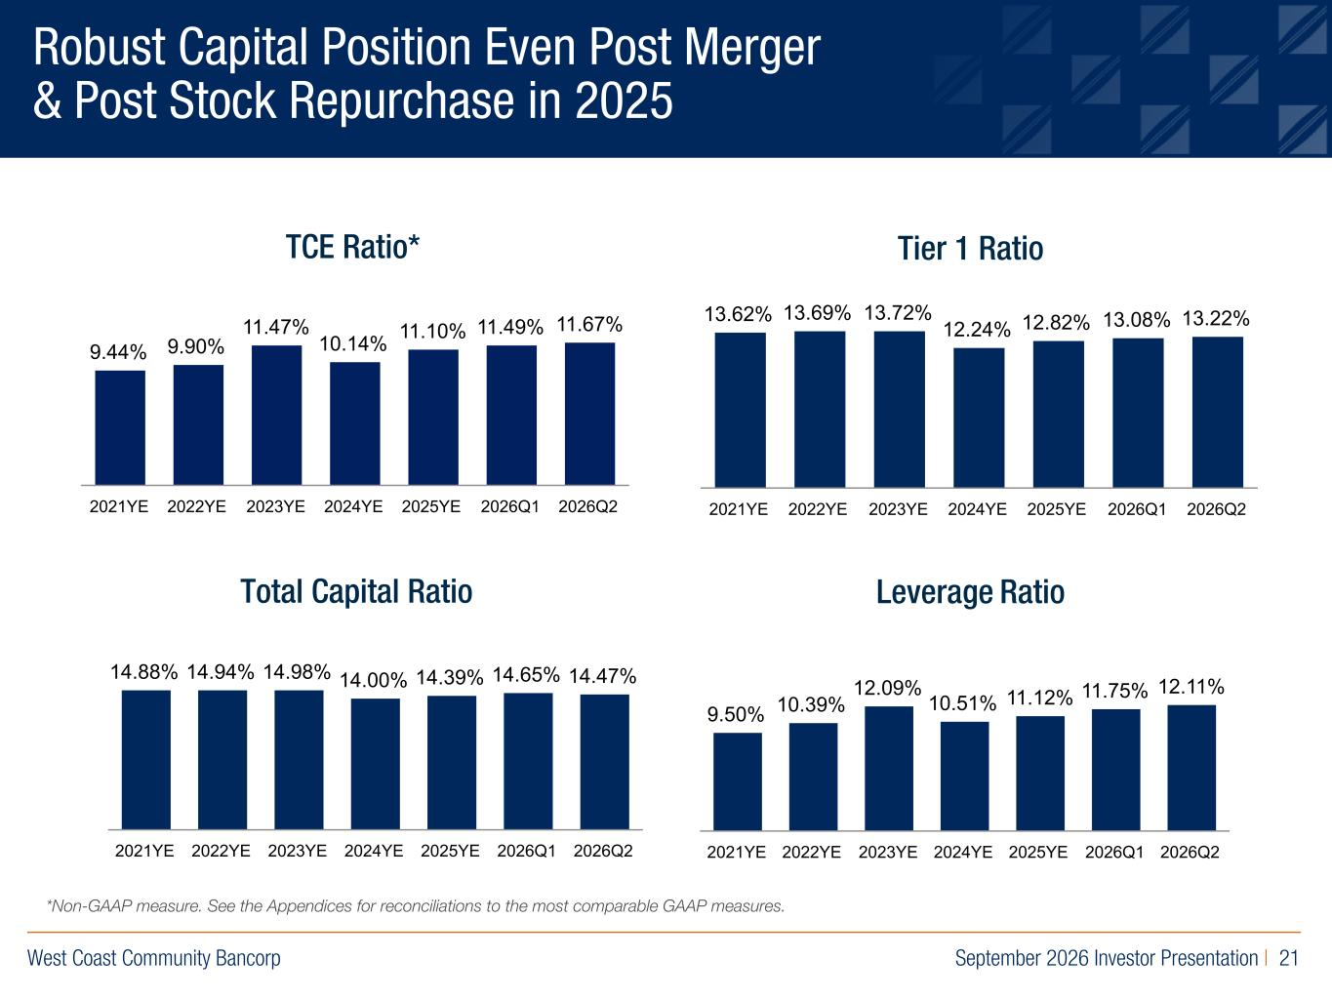
West Coast Community Bancorp September 2026 Investor Presentation | 21 R:219 G:109 B:29 R:0 G:40 B:93 R:155 G:154 B:163 Robust Capital Position Even Post Merger & Post Stock Repurchase in 2025 TCE Ratio* Tier 1 Ratio Total Capital Ratio Leverage Ratio 9.44% 9.90% 11.47% 10.14% 11.10% 11.49% 11.67% 2021YE 2022YE 2023YE 2024YE 2025YE 2026Q1 2026Q2 13.62% 13.69% 13.72% 12.24% 12.82% 13.08% 13.22% 2021YE 2022YE 2023YE 2024YE 2025YE 2026Q1 2026Q2 14.88% 14.94% 14.98% 14.00% 14.39% 14.65% 14.47% 2021YE 2022YE 2023YE 2024YE 2025YE 2026Q1 2026Q2 9.50% 10.39% 12.09% 10.51% 11.12% 11.75% 12.11% 2021YE 2022YE 2023YE 2024YE 2025YE 2026Q1 2026Q2 *NonGAAP measure. See the Appendices for reconciliations to the most comparable GAAP measures.

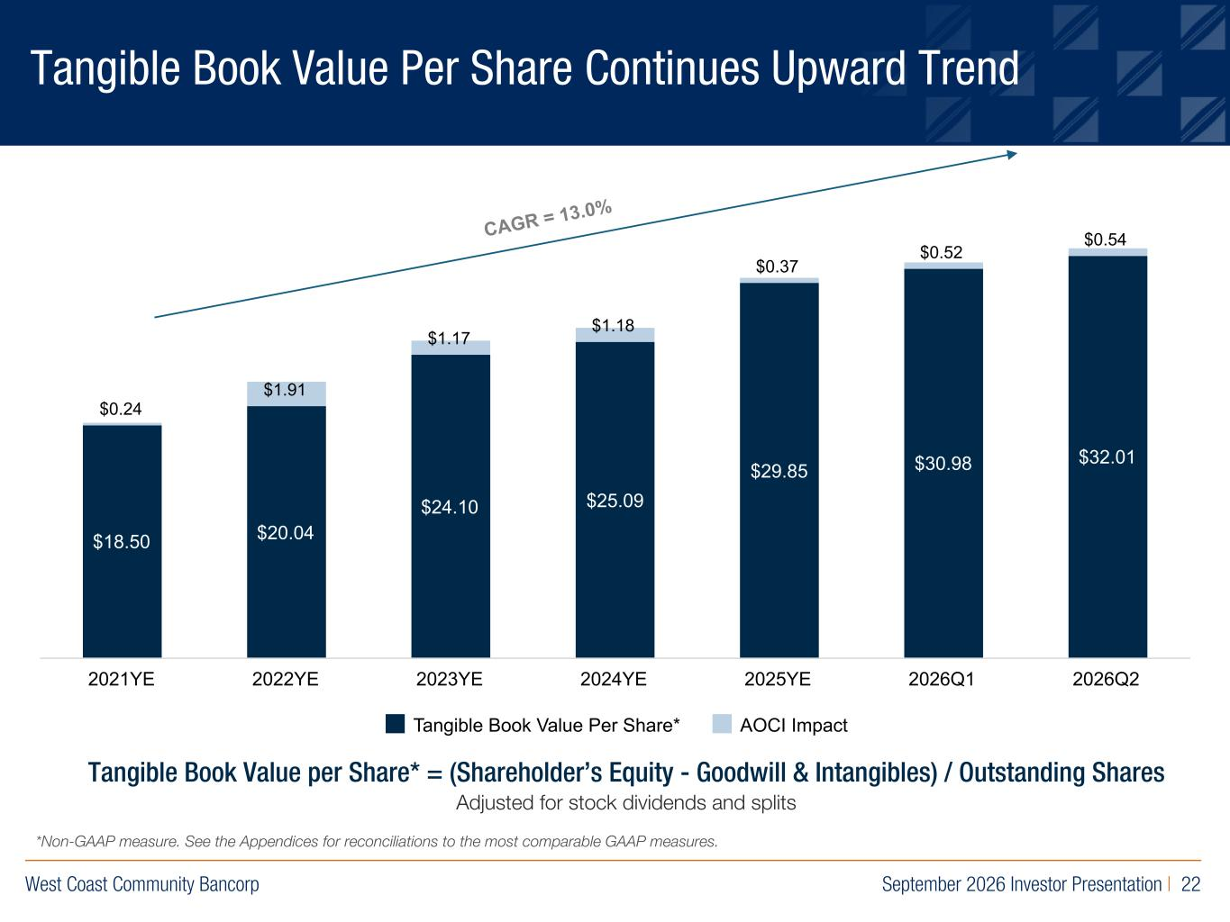
West Coast Community Bancorp September 2026 Investor Presentation | 22 R:219 G:109 B:29 R:0 G:40 B:93 R:155 G:154 B:163 Tangible Book Value Per Share Continues Upward Trend Tangible Book Value per Share* = (Shareholder’s Equity - Goodwill & Intangibles) / Outstanding Shares Adjusted for stock dividends and splits CAGR = 13.0% $18.50 $20.04 $24.10 $25.09 $29.85 $30.98 $32.01 $0.24 $1.91 $1.17 $1.18 $0.37 $0.52 $0.54 Tangible Book Value Per Share* AOCI Impact 2021YE 2022YE 2023YE 2024YE 2025YE 2026Q1 2026Q2 *NonGAAP measure. See the Appendices for reconciliations to the most comparable GAAP measures.

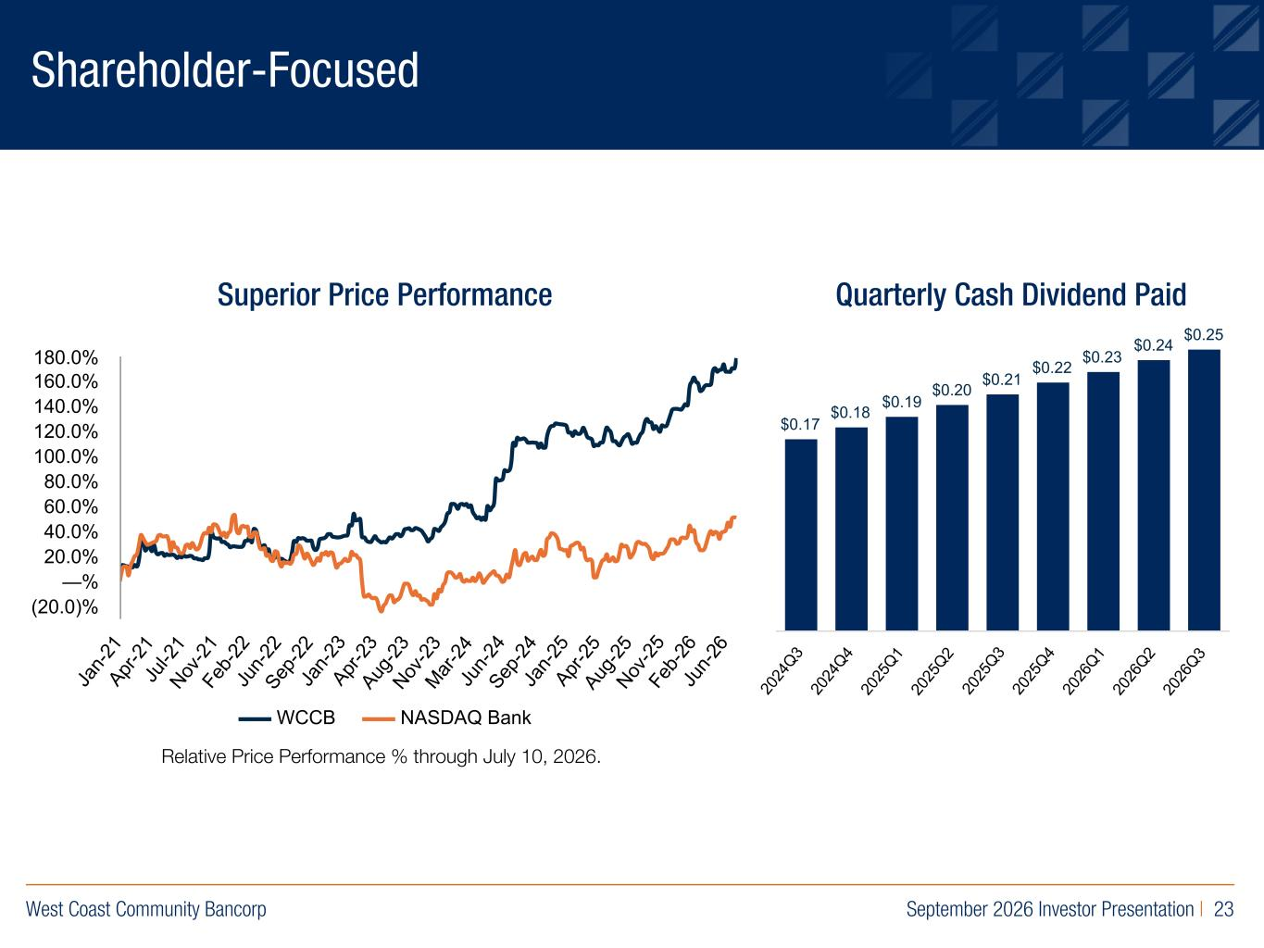
West Coast Community Bancorp September 2026 Investor Presentation | 23 R:219 G:109 B:29 R:0 G:40 B:93 R:155 G:154 B:163 Shareholder-Focused Superior Price Performance Quarterly Cash Dividend Paid Relative Price Performance % through July 10, 2026. WCCB NASDAQ Bank Ja n- 21 Apr -2 1 Ju l-2 1 Nov -2 1 Fe b- 22 Ju n- 22 Sep -2 2 Ja n- 23 Apr -2 3 Aug -2 3 Nov -2 3 Mar -2 4 Ju n- 24 Sep -2 4 Ja n- 25 Apr -2 5 Aug -2 5 Nov -2 5 Fe b- 26 Ju n- 26 (20.0)% —% 20.0% 40.0% 60.0% 80.0% 100.0% 120.0% 140.0% 160.0% 180.0% $0.17 $0.18 $0.19 $0.20 $0.21 $0.22 $0.23 $0.24 $0.25 20 24 Q3 20 24 Q4 20 25 Q1 20 25 Q2 20 25 Q3 20 25 Q4 20 26 Q1 20 26 Q2 20 26 Q3

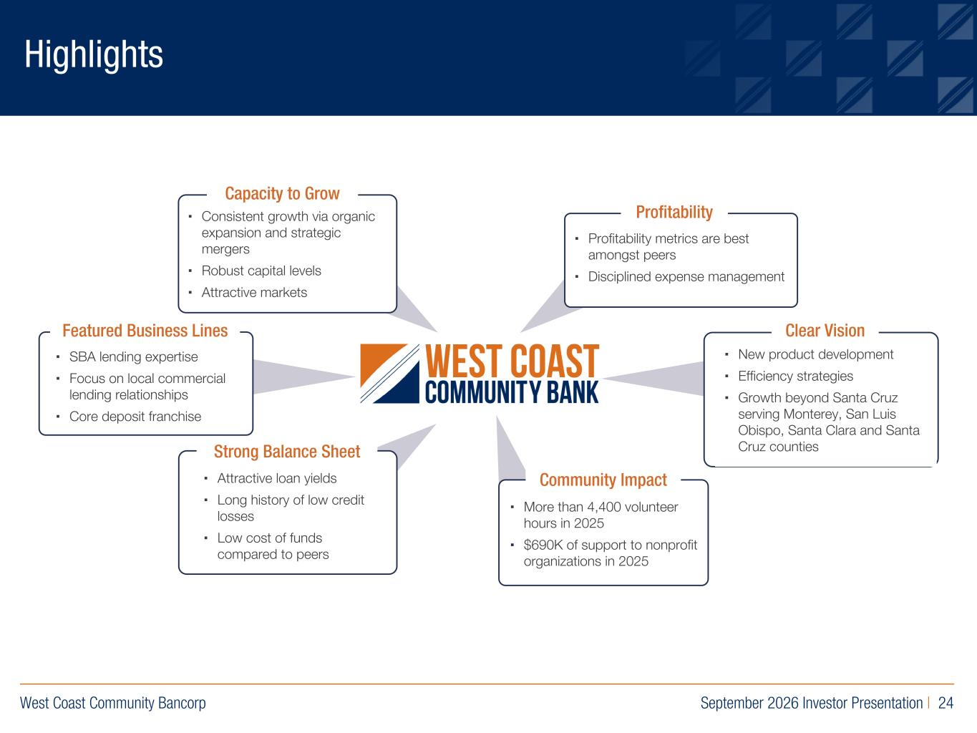
West Coast Community Bancorp September 2026 Investor Presentation | 24 R:219 G:109 B:29 R:0 G:40 B:93 R:155 G:154 B:163 Highlights Featured Business Lines ▪ SBA lending expertise ▪ Focus on local commercial lending relationships ▪ Core deposit franchise Strong Balance Sheet ▪ Attractive loan yields ▪ Long history of low credit losses ▪ Low cost of funds compared to peers Community Impact ▪ More than 4,400 volunteer hours in 2025 ▪ $690K of support to nonprofit organizations in 2025 Clear Vision ▪ New product development ▪ Efficiency strategies ▪ Growth beyond Santa Cruz serving Monterey, San Luis Obispo, Santa Clara and Santa Cruz counties Profitability ▪ Profitability metrics are best amongst peers ▪ Disciplined expense management Capacity to Grow ▪ Consistent growth via organic expansion and strategic mergers ▪ Robust capital levels ▪ Attractive markets

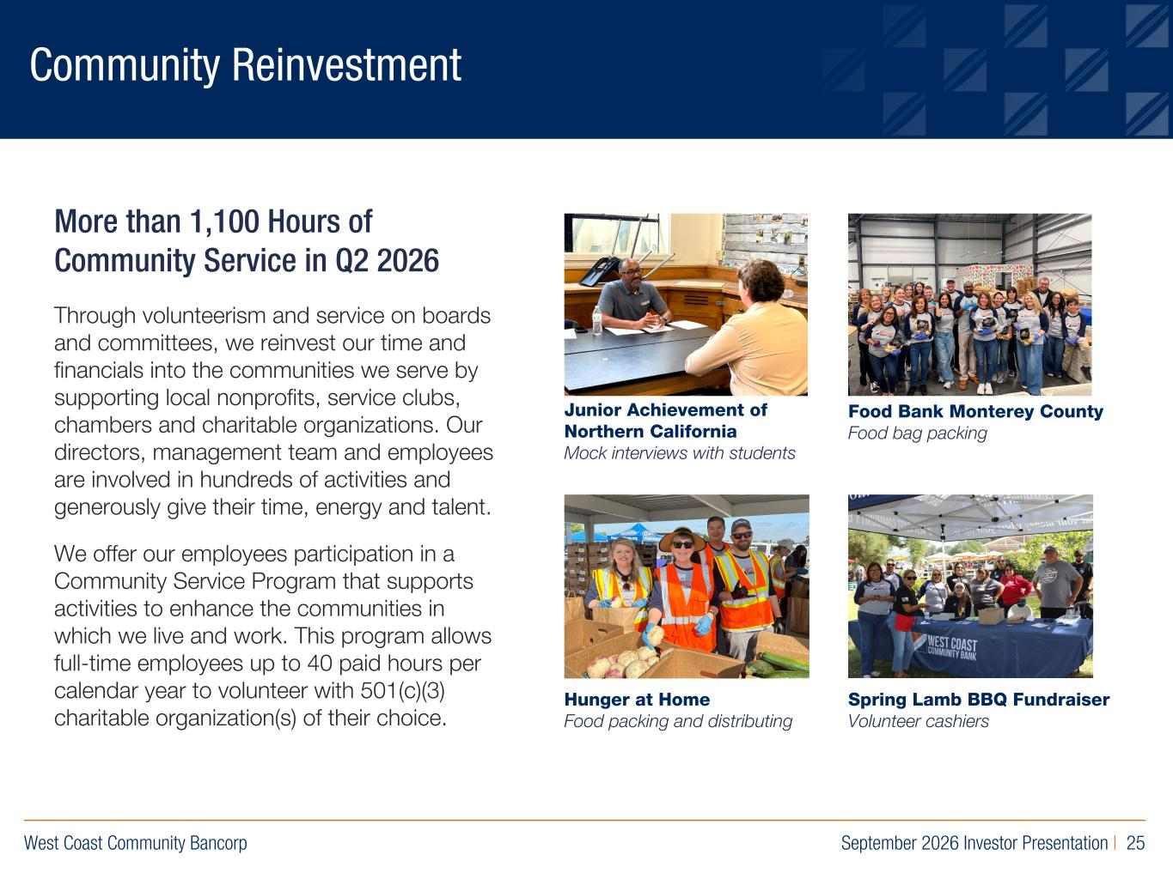
West Coast Community Bancorp September 2026 Investor Presentation | 25 R:219 G:109 B:29 R:0 G:40 B:93 R:155 G:154 B:163 Community Reinvestment More than 1,100 Hours of Community Service in Q2 2026 Through volunteerism and service on boards and committees, we reinvest our time and financials into the communities we serve by supporting local nonprofits, service clubs, chambers and charitable organizations. Our directors, management team and employees are involved in hundreds of activities and generously give their time, energy and talent. We offer our employees participation in a Community Service Program that supports activities to enhance the communities in which we live and work. This program allows full-time employees up to 40 paid hours per calendar year to volunteer with 501(c)(3) charitable organization(s) of their choice. Food Bank Monterey County Food bag packing Hunger at Home Food packing and distributing Junior Achievement of Northern California Mock interviews with students Spring Lamb BBQ Fundraiser Volunteer cashiers

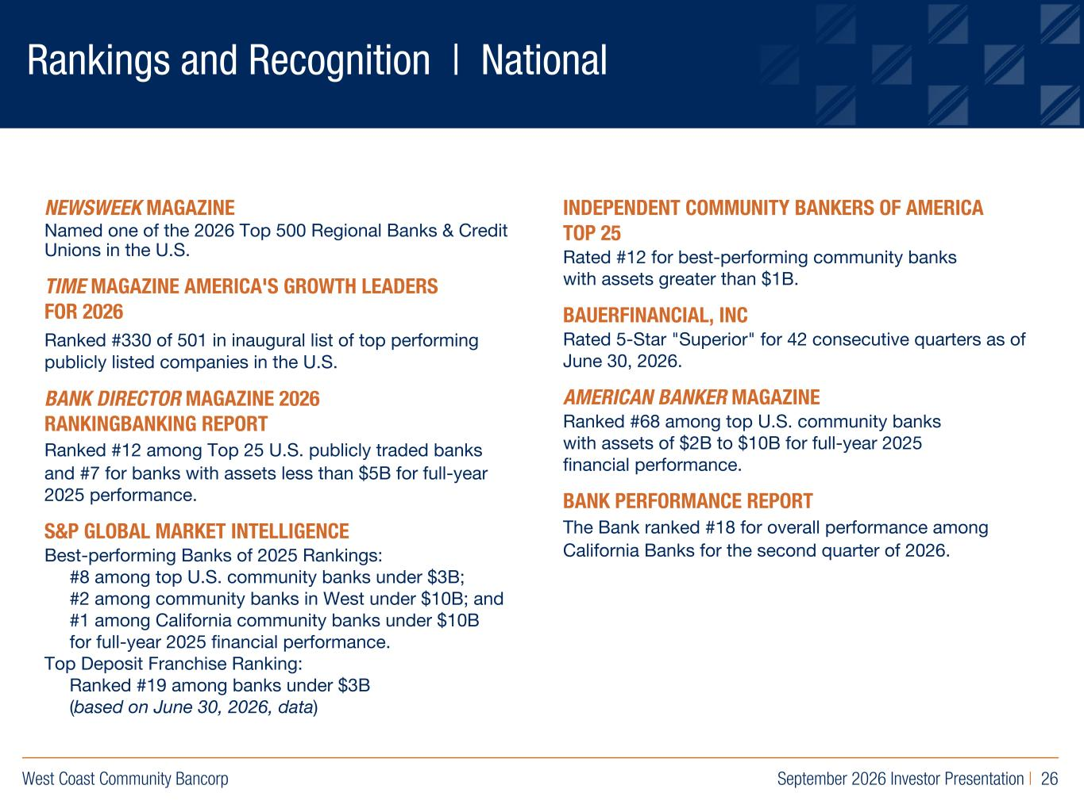
West Coast Community Bancorp September 2026 Investor Presentation | 26 R:219 G:109 B:29 R:0 G:40 B:93 R:155 G:154 B:163 Rankings and Recognition | National NEWSWEEK MAGAZINE Named one of the 2026 Top 500 Regional Banks & Credit Unions in the U.S. TIME MAGAZINE AMERICA'S GROWTH LEADERS FOR 2026 Ranked #330 of 501 in inaugural list of top performing publicly listed companies in the U.S. BANK DIRECTOR MAGAZINE 2026 RANKINGBANKING REPORT Ranked #12 among Top 25 U.S. publicly traded banks and #7 for banks with assets less than $5B for full-year 2025 performance. S&P GLOBAL MARKET INTELLIGENCE Best-performing Banks of 2025 Rankings: #8 among top U.S. community banks under $3B; #2 among community banks in West under $10B; and #1 among California community banks under $10B for full-year 2025 financial performance. Top Deposit Franchise Ranking: Ranked #19 among banks under $3B (based on June 30, 2026, data) INDEPENDENT COMMUNITY BANKERS OF AMERICA TOP 25 Rated #12 for best-performing community banks with assets greater than $1B. BAUERFINANCIAL, INC Rated 5-Star "Superior" for 42 consecutive quarters as of June 30, 2026. AMERICAN BANKER MAGAZINE Ranked #68 among top U.S. community banks with assets of $2B to $10B for full-year 2025 financial performance. BANK PERFORMANCE REPORT The Bank ranked #18 for overall performance among California Banks for the second quarter of 2026.

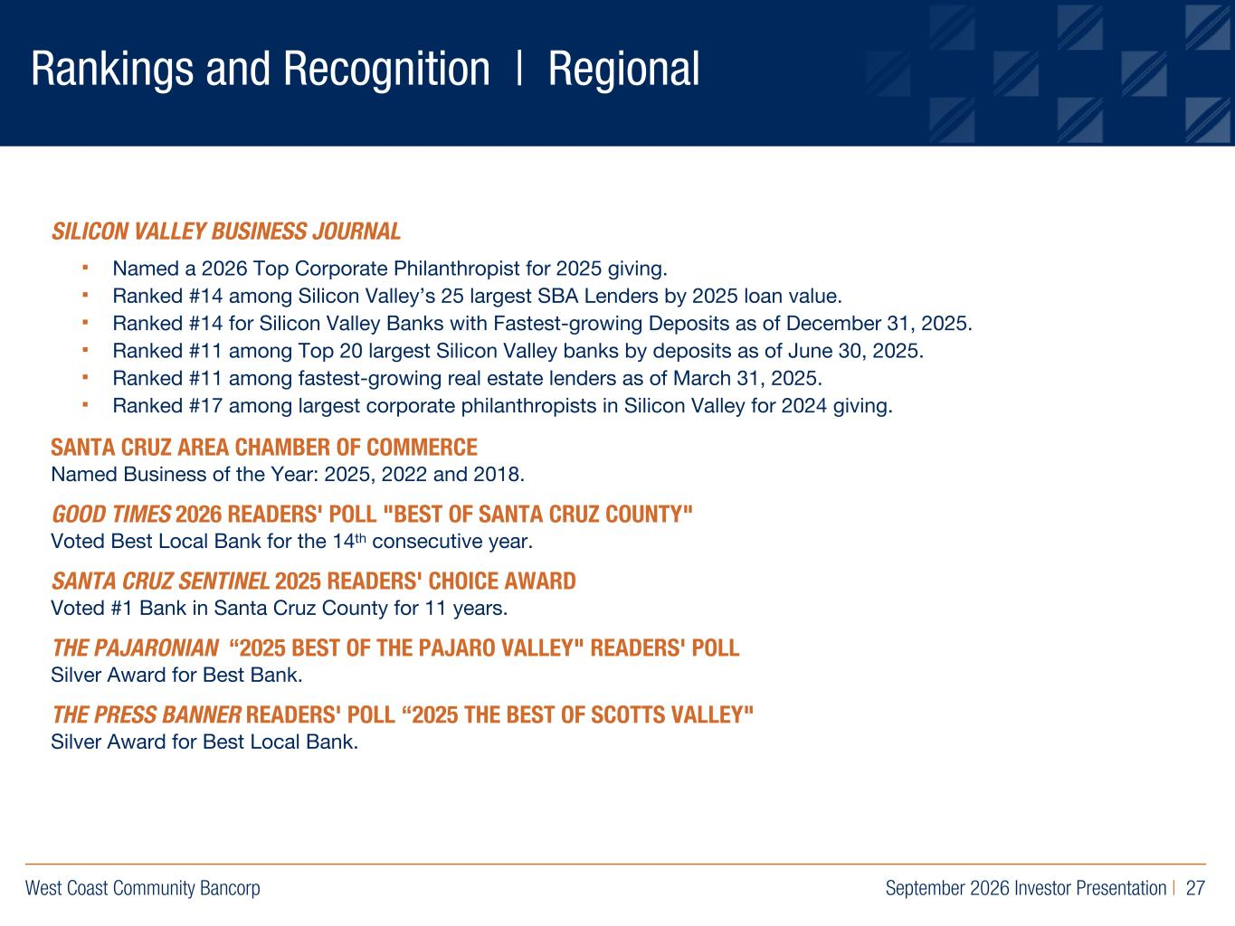
West Coast Community Bancorp September 2026 Investor Presentation | 27 R:219 G:109 B:29 R:0 G:40 B:93 R:155 G:154 B:163 Rankings and Recognition | Regional SILICON VALLEY BUSINESS JOURNAL ▪ Named a 2026 Top Corporate Philanthropist for 2025 giving. ▪ Ranked #14 among Silicon Valley’s 25 largest SBA Lenders by 2025 loan value. ▪ Ranked #14 for Silicon Valley Banks with Fastest-growing Deposits as of December 31, 2025. ▪ Ranked #11 among Top 20 largest Silicon Valley banks by deposits as of June 30, 2025. ▪ Ranked #11 among fastest-growing real estate lenders as of March 31, 2025. ▪ Ranked #17 among largest corporate philanthropists in Silicon Valley for 2024 giving. SANTA CRUZ AREA CHAMBER OF COMMERCE Named Business of the Year: 2025, 2022 and 2018. GOOD TIMES 2026 READERS' POLL "BEST OF SANTA CRUZ COUNTY" Voted Best Local Bank for the 14th consecutive year. SANTA CRUZ SENTINEL 2025 READERS' CHOICE AWARD Voted #1 Bank in Santa Cruz County for 11 years. THE PAJARONIAN “2025 BEST OF THE PAJARO VALLEY" READERS' POLL Silver Award for Best Bank. THE PRESS BANNER READERS' POLL “2025 THE BEST OF SCOTTS VALLEY" Silver Award for Best Local Bank.

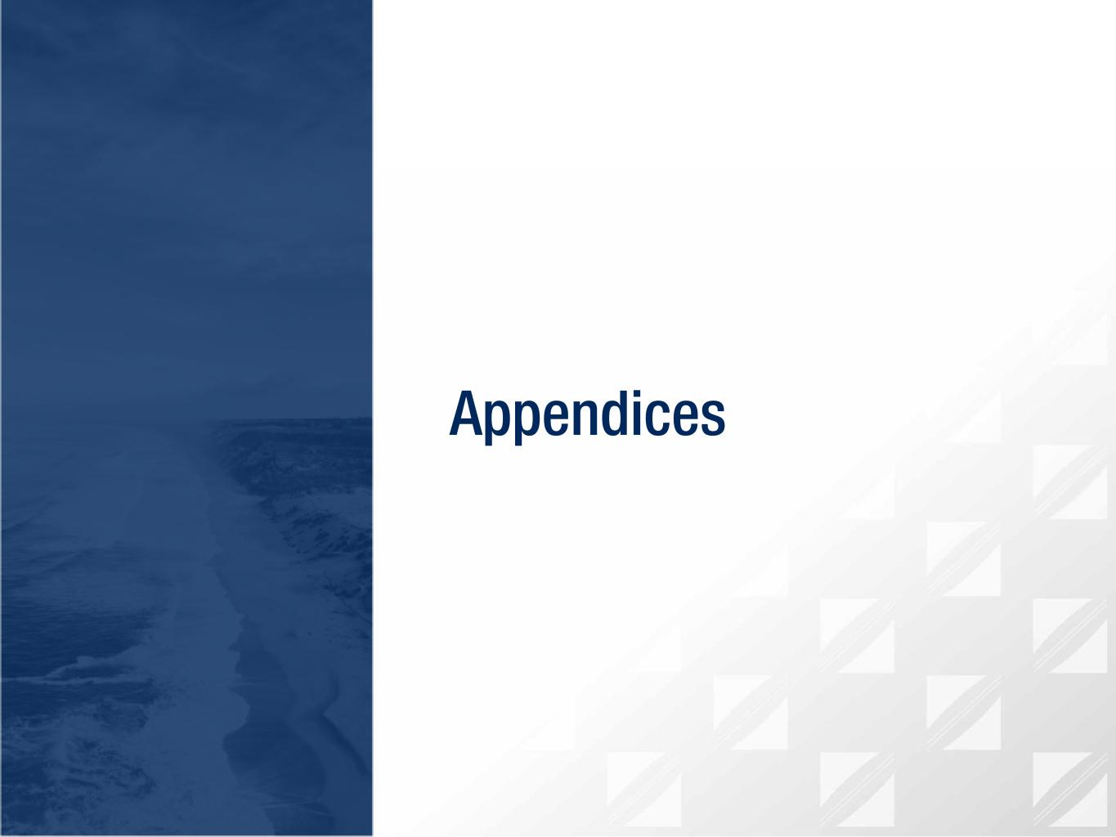
R:219 G:109 B:29 R:0 G:40 B:93 R:155 G:154 B:163 Appendices

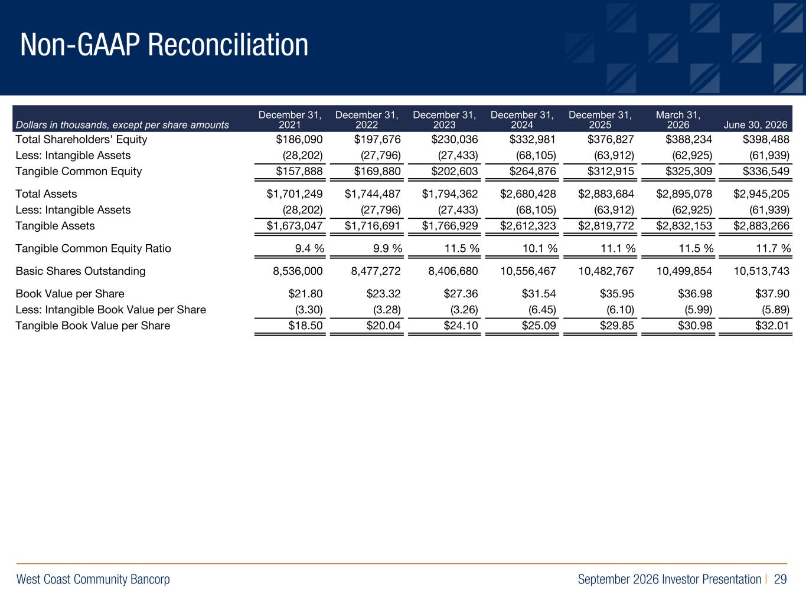
West Coast Community Bancorp September 2026 Investor Presentation | 29 R:219 G:109 B:29 R:0 G:40 B:93 R:155 G:154 B:163 Non-GAAP Reconciliation Dollars in thousands, except per share amounts December 31, 2021 December 31, 2022 December 31, 2023 December 31, 2024 December 31, 2025 March 31, 2026 June 30, 2026 Total Shareholders' Equity $186,090 $197,676 $230,036 $332,981 $376,827 $388,234 $398,488 Less: Intangible Assets (28,202) (27,796) (27,433) (68,105) (63,912) (62,925) (61,939) Tangible Common Equity $157,888 $169,880 $202,603 $264,876 $312,915 $325,309 $336,549 Total Assets $1,701,249 $1,744,487 $1,794,362 $2,680,428 $2,883,684 $2,895,078 $2,945,205 Less: Intangible Assets (28,202) (27,796) (27,433) (68,105) (63,912) (62,925) (61,939) Tangible Assets $1,673,047 $1,716,691 $1,766,929 $2,612,323 $2,819,772 $2,832,153 $2,883,266 Tangible Common Equity Ratio 9.4 % 9.9 % 11.5 % 10.1 % 11.1 % 11.5 % 11.7 % Basic Shares Outstanding 8,536,000 8,477,272 8,406,680 10,556,467 10,482,767 10,499,854 10,513,743 Book Value per Share $21.80 $23.32 $27.36 $31.54 $35.95 $36.98 $37.90 Less: Intangible Book Value per Share (3.30) (3.28) (3.26) (6.45) (6.10) (5.99) (5.89) Tangible Book Value per Share $18.50 $20.04 $24.10 $25.09 $29.85 $30.98 $32.01

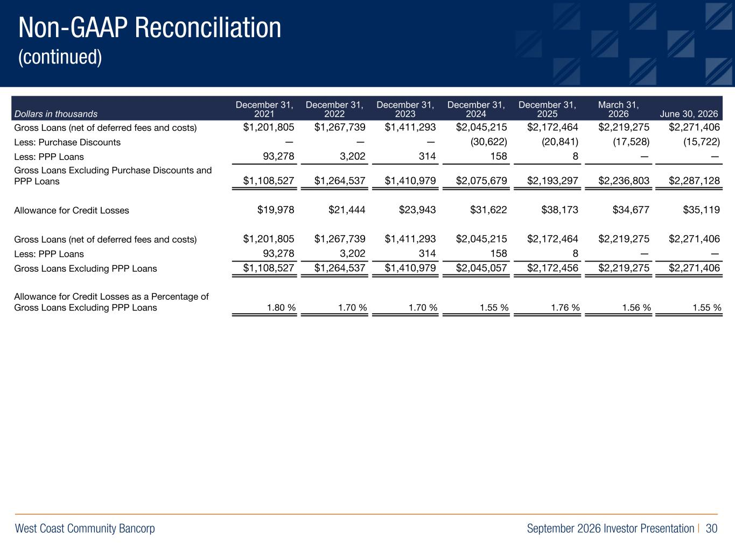
West Coast Community Bancorp September 2026 Investor Presentation | 30 R:219 G:109 B:29 R:0 G:40 B:93 R:155 G:154 B:163 Non-GAAP Reconciliation (continued) Dollars in thousands December 31, 2021 December 31, 2022 December 31, 2023 December 31, 2024 December 31, 2025 March 31, 2026 June 30, 2026 Gross Loans (net of deferred fees and costs) $1,201,805 $1,267,739 $1,411,293 $2,045,215 $2,172,464 $2,219,275 $2,271,406 Less: Purchase Discounts — — — (30,622) (20,841) (17,528) (15,722) Less: PPP Loans 93,278 3,202 314 158 8 — — Gross Loans Excluding Purchase Discounts and PPP Loans $1,108,527 $1,264,537 $1,410,979 $2,075,679 $2,193,297 $2,236,803 $2,287,128 Allowance for Credit Losses $19,978 $21,444 $23,943 $31,622 $38,173 $34,677 $35,119 Gross Loans (net of deferred fees and costs) $1,201,805 $1,267,739 $1,411,293 $2,045,215 $2,172,464 $2,219,275 $2,271,406 Less: PPP Loans 93,278 3,202 314 158 8 — — Gross Loans Excluding PPP Loans $1,108,527 $1,264,537 $1,410,979 $2,045,057 $2,172,456 $2,219,275 $2,271,406 Allowance for Credit Losses as a Percentage of Gross Loans Excluding PPP Loans 1.80 % 1.70 % 1.70 % 1.55 % 1.76 % 1.56 % 1.55 %

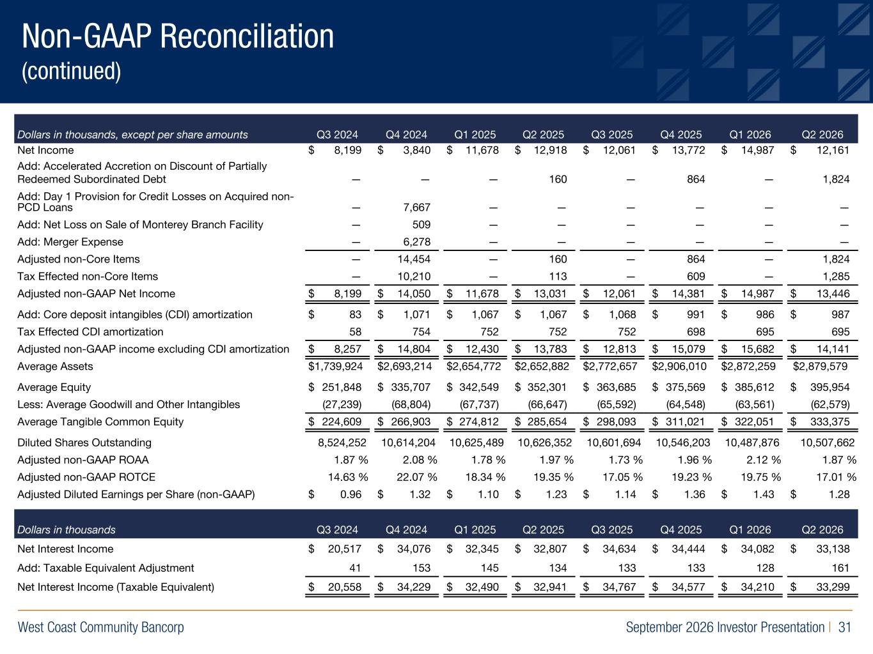
West Coast Community Bancorp September 2026 Investor Presentation | 31 R:219 G:109 B:29 R:0 G:40 B:93 R:155 G:154 B:163 Non-GAAP Reconciliation (continued) Dollars in thousands, except per share amounts Q3 2024 Q4 2024 Q1 2025 Q2 2025 Q3 2025 Q4 2025 Q1 2026 Q2 2026 Net Income $ 8,199 $ 3,840 $ 11,678 $ 12,918 $ 12,061 $ 13,772 $ 14,987 $ 12,161 Add: Accelerated Accretion on Discount of Partially Redeemed Subordinated Debt — — — 160 — 864 — 1,824 Add: Day 1 Provision for Credit Losses on Acquired non PCD Loans — 7,667 — — — — — — Add: Net Loss on Sale of Monterey Branch Facility — 509 — — — — — — Add: Merger Expense — 6,278 — — — — — — Adjusted nonCore Items — 14,454 — 160 — 864 — 1,824 Tax Effected nonCore Items — 10,210 — 113 — 609 — 1,285 Adjusted nonGAAP Net Income $ 8,199 $ 14,050 $ 11,678 $ 13,031 $ 12,061 $ 14,381 $ 14,987 $ 13,446 Add: Core deposit intangibles (CDI) amortization $ 83 $ 1,071 $ 1,067 $ 1,067 $ 1,068 $ 991 $ 986 $ 987 Tax Effected CDI amortization 58 754 752 752 752 698 695 695 Adjusted nonGAAP income excluding CDI amortization $ 8,257 $ 14,804 $ 12,430 $ 13,783 $ 12,813 $ 15,079 $ 15,682 $ 14,141 Average Assets $ 1,739,924 $ 2,693,214 $ 2,654,772 $ 2,652,882 $ 2,772,657 $ 2,906,010 $ 2,872,259 $2,879,579 Average Equity $ 251,848 $ 335,707 $ 342,549 $ 352,301 $ 363,685 $ 375,569 $ 385,612 $ 395,954 Less: Average Goodwill and Other Intangibles (27,239) (68,804) (67,737) (66,647) (65,592) (64,548) (63,561) (62,579) Average Tangible Common Equity $ 224,609 $ 266,903 $ 274,812 $ 285,654 $ 298,093 $ 311,021 $ 322,051 $ 333,375 Diluted Shares Outstanding 8,524,252 10,614,204 10,625,489 10,626,352 10,601,694 10,546,203 10,487,876 10,507,662 Adjusted nonGAAP ROAA 1.87 % 2.08 % 1.78 % 1.97 % 1.73 % 1.96 % 2.12 % 1.87 % Adjusted nonGAAP ROTCE 14.63 % 22.07 % 18.34 % 19.35 % 17.05 % 19.23 % 19.75 % 17.01 % Adjusted Diluted Earnings per Share (nonGAAP) $ 0.96 $ 1.32 $ 1.10 $ 1.23 $ 1.14 $ 1.36 $ 1.43 $ 1.28 Dollars in thousands Q3 2024 Q4 2024 Q1 2025 Q2 2025 Q3 2025 Q4 2025 Q1 2026 Q2 2026 Net Interest Income $ 20,517 $ 34,076 $ 32,345 $ 32,807 $ 34,634 $ 34,444 $ 34,082 $ 33,138 Add: Taxable Equivalent Adjustment 41 153 145 134 133 133 128 161 Net Interest Income (Taxable Equivalent) $ 20,558 $ 34,229 $ 32,490 $ 32,941 $ 34,767 $ 34,577 $ 34,210 $ 33,299

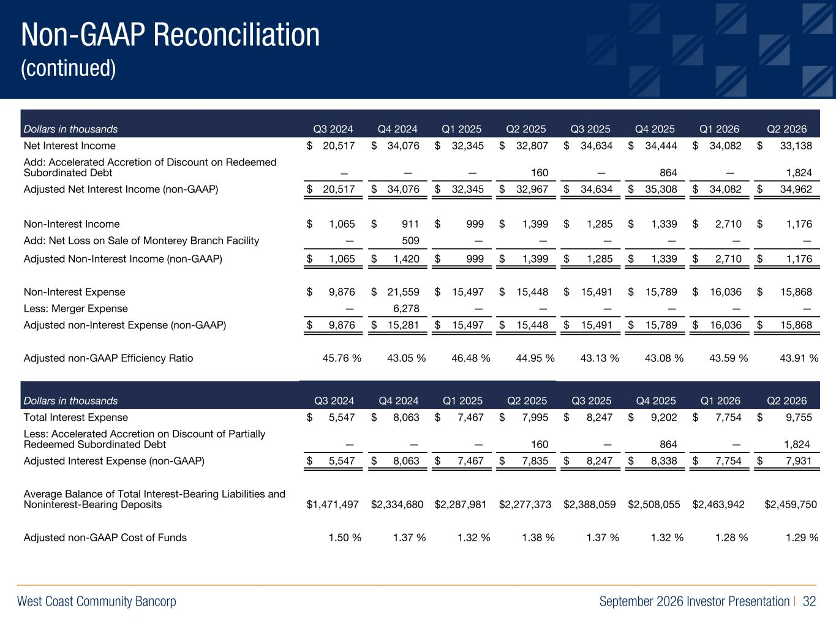
West Coast Community Bancorp September 2026 Investor Presentation | 32 R:219 G:109 B:29 R:0 G:40 B:93 R:155 G:154 B:163 Dollars in thousands Q3 2024 Q4 2024 Q1 2025 Q2 2025 Q3 2025 Q4 2025 Q1 2026 Q2 2026 Net Interest Income $ 20,517 $ 34,076 $ 32,345 $ 32,807 $ 34,634 $ 34,444 $ 34,082 $ 33,138 Add: Accelerated Accretion of Discount on Redeemed Subordinated Debt — — — 160 — 864 — 1,824 Adjusted Net Interest Income (nonGAAP) $ 20,517 $ 34,076 $ 32,345 $ 32,967 $ 34,634 $ 35,308 $ 34,082 $ 34,962 NonInterest Income $ 1,065 $ 911 $ 999 $ 1,399 $ 1,285 $ 1,339 $ 2,710 $ 1,176 Add: Net Loss on Sale of Monterey Branch Facility — 509 — — — — — — Adjusted NonInterest Income (nonGAAP) $ 1,065 $ 1,420 $ 999 $ 1,399 $ 1,285 $ 1,339 $ 2,710 $ 1,176 NonInterest Expense $ 9,876 $ 21,559 $ 15,497 $ 15,448 $ 15,491 $ 15,789 $ 16,036 $ 15,868 Less: Merger Expense — 6,278 — — — — — — Adjusted nonInterest Expense (nonGAAP) $ 9,876 $ 15,281 $ 15,497 $ 15,448 $ 15,491 $ 15,789 $ 16,036 $ 15,868 Adjusted nonGAAP Efficiency Ratio 45.76 % 43.05 % 46.48 % 44.95 % 43.13 % 43.08 % 43.59 % 43.91 % Dollars in thousands Q3 2024 Q4 2024 Q1 2025 Q2 2025 Q3 2025 Q4 2025 Q1 2026 Q2 2026 Total Interest Expense $ 5,547 $ 8,063 $ 7,467 $ 7,995 $ 8,247 $ 9,202 $ 7,754 $ 9,755 Less: Accelerated Accretion on Discount of Partially Redeemed Subordinated Debt — — — 160 — 864 — 1,824 Adjusted Interest Expense (nonGAAP) $ 5,547 $ 8,063 $ 7,467 $ 7,835 $ 8,247 $ 8,338 $ 7,754 $ 7,931 Average Balance of Total InterestBearing Liabilities and NoninterestBearing Deposits $ 1,471,497 $ 2,334,680 $ 2,287,981 $ 2,277,373 $ 2,388,059 $ 2,508,055 $ 2,463,942 $2,459,750 Adjusted nonGAAP Cost of Funds 1.50 % 1.37 % 1.32 % 1.38 % 1.37 % 1.32 % 1.28 % 1.29 % Non-GAAP Reconciliation (continued)

